Tractor Supply Company DC Human Resoruces Summer Internship Opportunity (On-Site)
Hagerstown, MD

Location: Hagerstown, MD
Who: Must be enrolled in or recently graduated from an accredited university; rising seniors preferred
Website: Application Link & Information
Summer hourly rate: $20-$25/hour (depending on the candidate’s major and year in school)
Internship dates: May 18 - July 31, 2026 (11 weeks)
Relocation stipend: $2,500
Internship Description: (DC HR Intern)
This is an 11-week rotational internship at Tractor Supply’s Hagerstown, MD Distribution Center, designed to provide hands-on exposure to Human Resources functions. Interns will work closely with HR leaders across areas such as talent acquisition, onboarding, employee relations, training and development, benefits administration, and compliance to understand how HR drives engagement and supports operational success.

Throughout the program, you’ll take ownership of meaningful projects focused on enhancing team member experience, improving HR processes, and supporting workforce development initiatives. Using data and observations, you’ll develop and present solutions that create a positive impact on both employees and the organization.

The internship includes structured mentorship and coaching from HR professionals, as well as opportunities for leadership development. At the conclusion of the program, interns will present their findings and project outcomes to Distribution Center leadership.


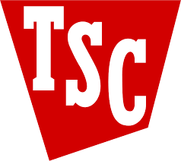

Scan to Apply!
Company Overview & History

