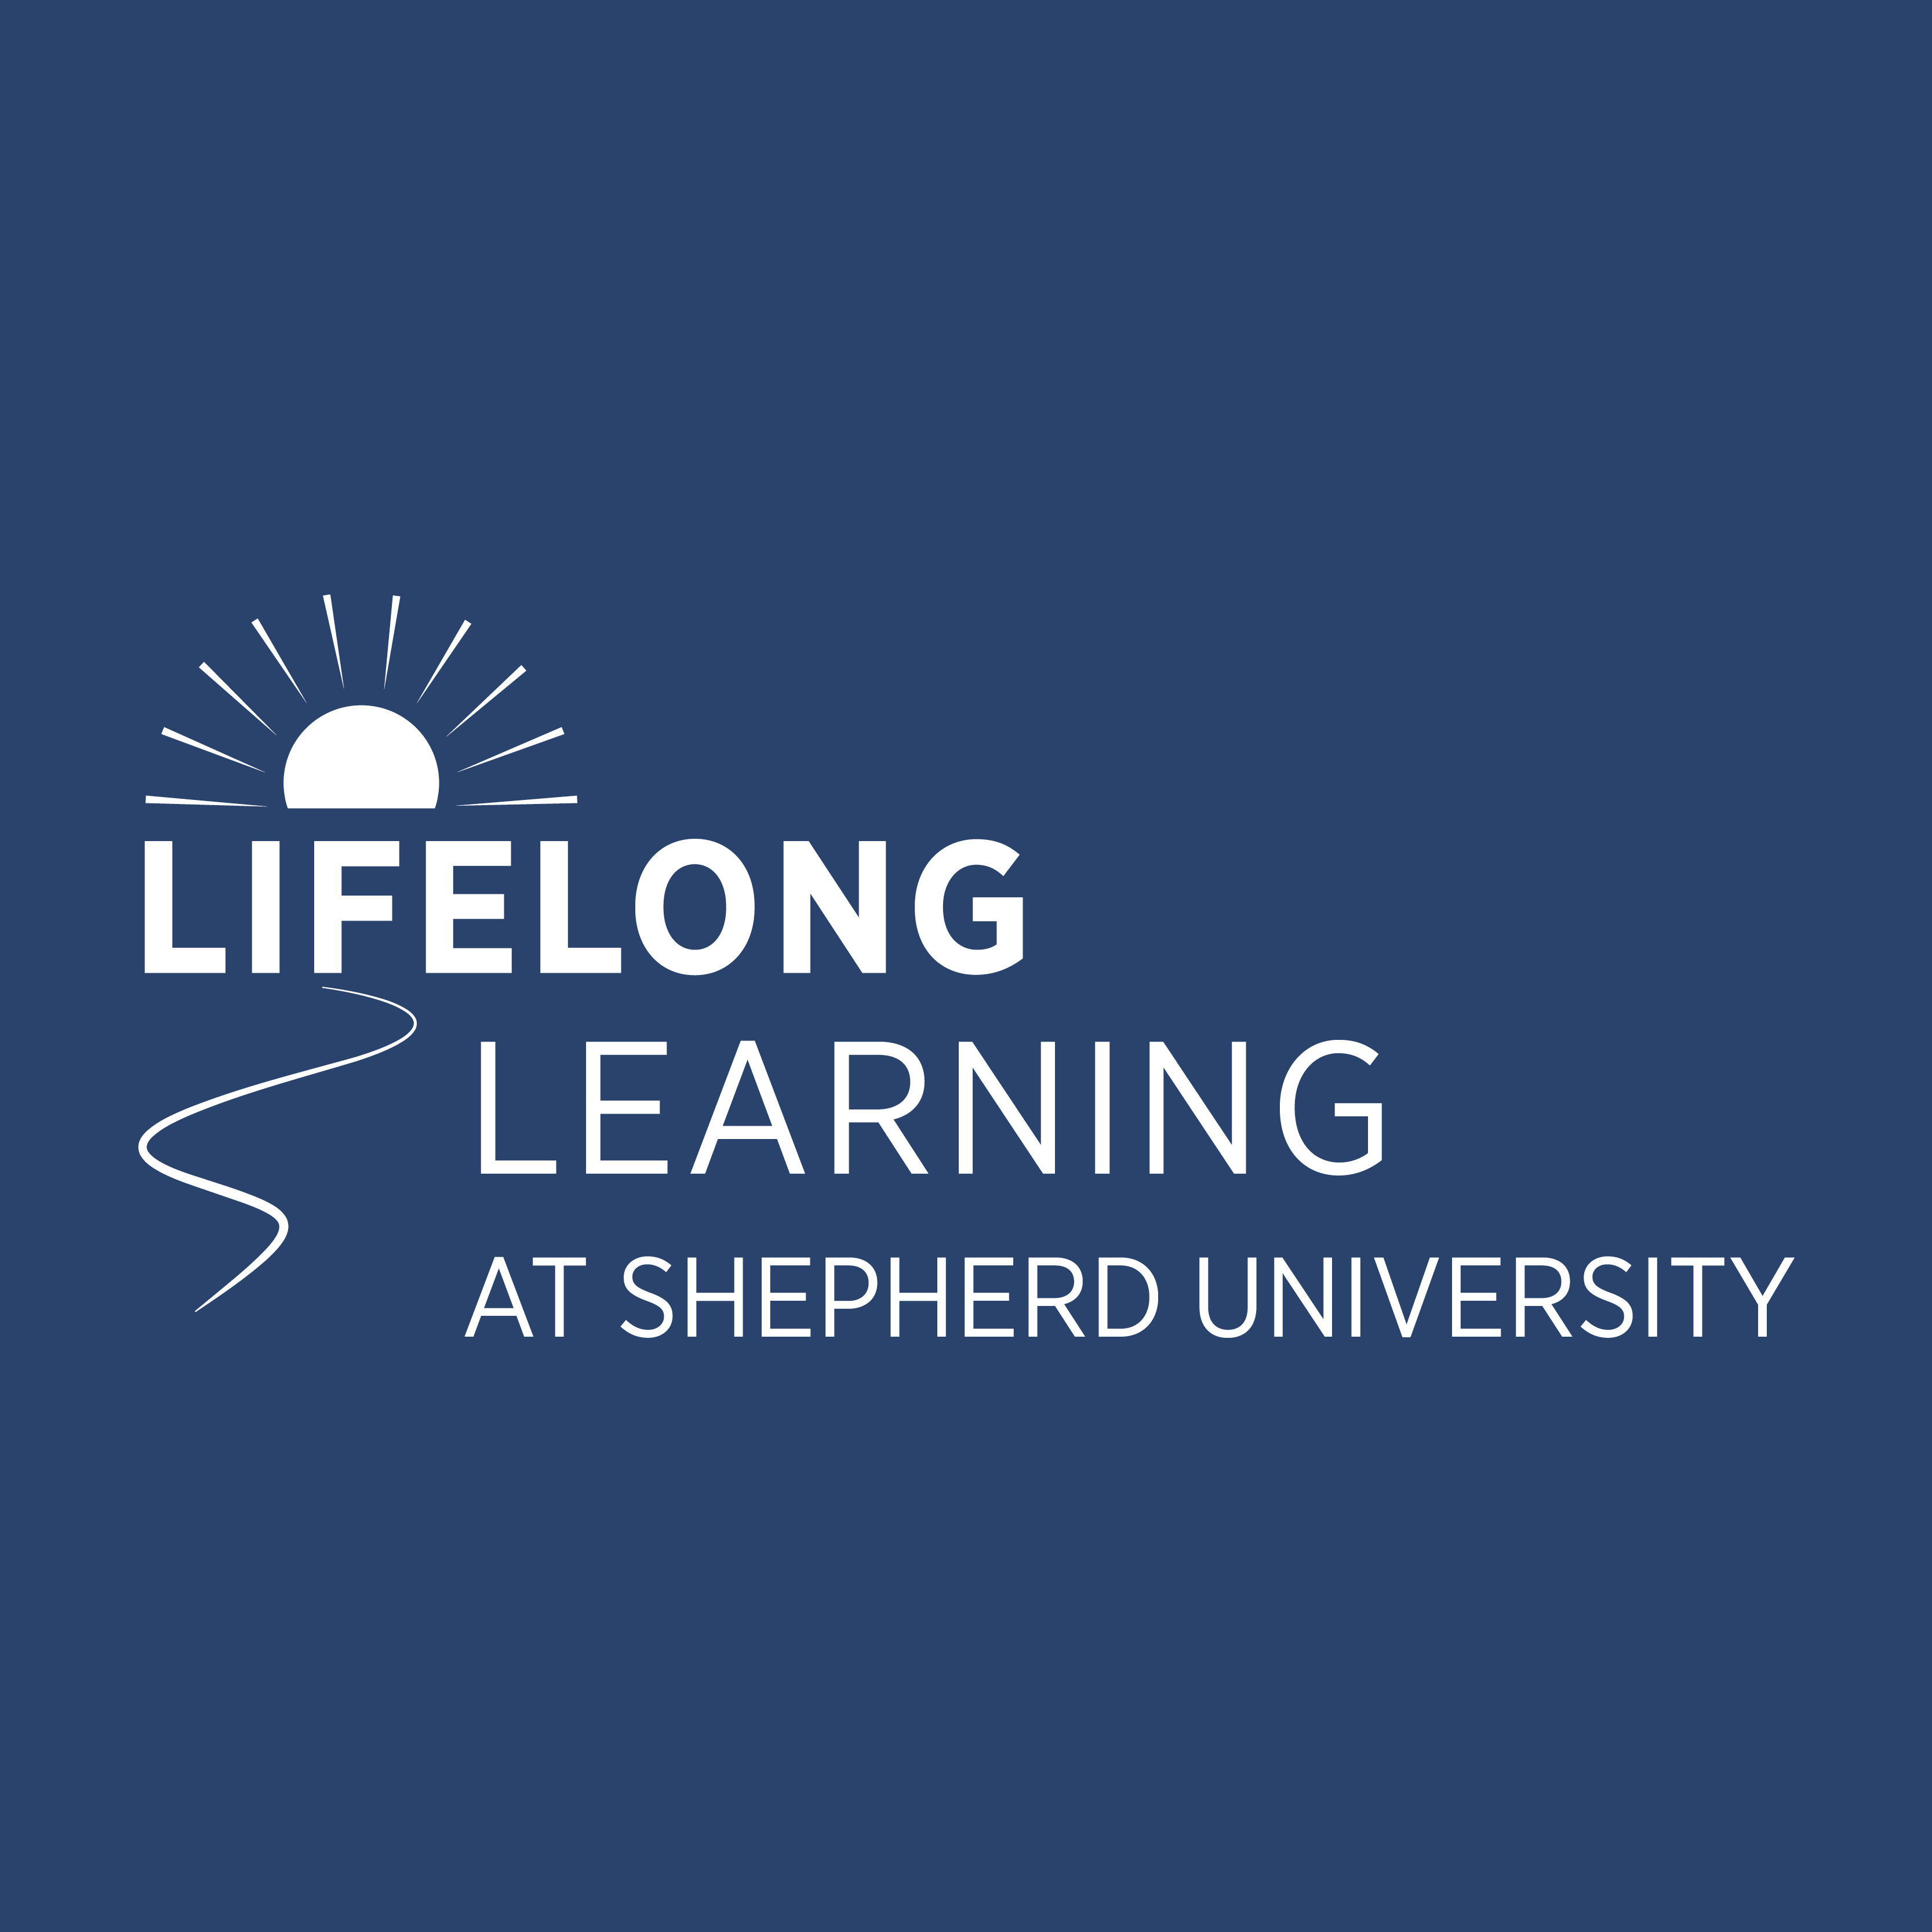
Lifelong Learning Program Fall 2023 Registration Form
Beginning September 11

Annual Gold Membership (course fees included) $340 ______
For Gold Member spouses/partners $185 ______
Annual Silver Membership (course fees not included) $90 ______
First-Time Student $99 ______

Courses Course Length Fee
□ Actions for Happiness and Conscious Living (9/11) for 6 weeks $63 ______
□ American Indian Burial Practices (9/15) for 6 weeks $63 ______
□ A Plant-Based Diet: The What, Why and How (9/13) for 3 weeks $32 ______
□ A 21st Century Phenomenon? The Politics of Flesh-Eating Zombies (9/15) for 6 weeks $63 ______
□ Bel Canto Opera: Rossini, Donizetti & Bellini (9/12) for 6 weeks $63 ______
□ Bob Dylan: Just a Song & Dance Man (9/13) for 6 weeks $63 ______
□ Café Society Discussion Group Every Tuesday except for Holidays Free
□ Current International Issues Discussion Group (9/14) for 6 weeks $63 ______
□ Deep Dives – Podcasts as a Vehicle for Long Form Exploration of Ideas (9/14) for 6 weeks $63 ______
□ Everyday Art in Line, Wash & Collage (3/29) for 6 weeks free ______
□ Memoir Seminar: Putting Your Life into Words (part 2) (9/14) for 6 weeks $63 ______
□ Middlemarch (10/25) for 8 sessions $63 ______
□ Mindfulness & Meditation: Strategies for Living in Uncertain Times (9/11) for 6 weeks $63 ______
□ 2023 One Book One West Virginia Common Read Author Ann Pancake (9/14) for 2 weeks $32 ______
□ Proust Without Pain (9/14) for 6 weeks $63 ______
□ Retirement Planning Workshop - Thursday (9/28 & 10/5) for 2 weeks $49 ______
□ Retirement Planning Workshop - Saturday (9/30 & 10/7) for 2 weeks $49 ______
□ Short Stories: Sight and Sound (9/12) for 6 weeks $63 ______
□ Tales from the Circulus Lacteus … aka Galaxy (9/13) for 5 weeks $63 ______
□ The Church in Medieval Times (9/11) for 6 weeks $63 ______
□ The Game’s Afoot! Further Explorations into Sherlock Holmes (9/11) for 6 weeks $63 ______
□ The Irony of Democracy (9/14) for 6 weeks $63 ______
□ The Magical History Tour and Talk – History Makers in Jefferson County (9/15) for 6 weeks $63 ______
□ The Power of Poetry and Song Lyrics (9/11) for 7 weeks $63 ______
□ Transitions – Getting a Grip on Upheaval and Change (9/12) for 6 weeks $63 ______
□ Wild Writers Retreat at Cacapon Springs & Farm (10/29 – 11/1) $425/member; $475 / non-member

FASTEnER Lab Courses (All Lab Courses have additional Marterial or Lab Fees)
□ Introduction to Mig Welding (+175 lab fee) 6 weeks $63 ______
□ 3-D Printing for Metal Casting (+ $250 lab fee) 7 weeks $63 ______
□ Creating Decorative Cutting Boards (+ $100 lab fee) – 1st session 3 weeks $32 ______
□ Creating Decorative Cutting Boards (+ $100 lab fee) – 2nd session 3 weeks $32 ______
□ Advanced Open Lab (+ $200 lab fee) All Semester $63 ______

Brown Bag Luncheon Lectures
□ Brevet Lieutenant Colonel Joseph Wiley Gelray: How a Maimed Union Veteran (8/30) $15 ______
Battled the Ku Klux Klan
□ Like a Rolling Stone: The Making of the Greatest Rock ‘n Roll Song Ever (9/6) $15 ______
□ The “Taiwan Issue” and its Possible Regional and Global Implications (9/13) $15 ______
□ Diversity and Consciousness: A Past Life Regression Story (9/20) $15 ______
□ Filthy Rich Politicians (9/27) $15 ______
□ Confused About Medicare (10/4) free ______
□ Cradle of American Values? Here? (10/11) $15 ______
□ Bustin’ Suds and Greasin’ the Rails: The Signs, Songs, Poems & Argot of (10/18) $15 ______
the American Hobo
□ You Burned the Wrong Lady’s House! Shepherdstown Burnings of 1864 (10/25) $15 ______
□ Nazism and Philosophy: Re-Reading Heidegger (11/8) $15 ______

President’s Lectures
□ Public Service, Shepherd International, Disruptive Technology (9/12) free ______
□ China’s Access to U.S. Technology (10/23) free ______
□ Crucible of Law and War: International Humanitarian Law & Preservation (11/27) free ______

Day Tours & Events
□ Glenstone Museum (9/7) $109/99 ______
□ Hillwood Estate Museum & Gardens (10/27) $179/159 ______
□ Shepherd Football Game with Pregame Reception (11/4) $45 ______

National & International Tours
□ Civil Rights Tour of Alabama & Atlanta $3,000** ______
□ Venice & the Italian Lakes $4,875** ______
□ Colorful Costa Rica $3,625** ______
□ Alaska: Call of the Wild $5,699** ______
□ Utah’s Mighty National Parks $3,525** ______
□ Highlights of the Duoro with Spain $5,095** ______
□ Greece Island Hopper $4,999** ______

TOTAL ______
** Based on Double Occupancy with booking discount; call for Single Occupancy price

Information
Name: □ Dr. □ Mr. □ Mrs. □ Ms. ____________________________________________________________________
Spouse/Partner’s Name: _________________________________________________________________________________
Alumnus/Alumna of Shepherd? □Yes □No Class Year: _______________________
Telephone: ________________________________ E-mail: _____________________________________________
Address: ______________________________________________________________________________________________
______________________________________________________________________________________________________

I AM PLANNING TO ATTEND IN PERSON. _____Yes _____No
I WILL BE ATTENDING USING ZOOM. _____Yes _____No

How did you learn about these Lifelong Learning courses, lectures and trips? (Check all that apply)
□ Email □ Brochure in mail □ Picked up brochure in community □ Newspaper article □ Word of Mouth □ Other
________________________________________________________________________________________

____ I would like to volunteer in the Lifelong Learning Program. Please contact me.

Payment
□ Check (Make payable to Shepherd University) OR
□ Credit Card: □ VISA □ MasterCard □ Discover □ American Express
Account #: ____________________________________________________________________________________________
Expiration Date: _____________________________ Security Code: ___________________________
Total Fee: _____________________ Billing address same as above? □ Yes □No (if no, please provide billing address) _____________________________________________________________________________________________________
Print Name: ___________________________________________________________________________________________
Signature: ____________________________________________________________________________________________

I would like to support the Lifelong Learning Program with my tax-deductible gift. Your gift is a gift of learning that helps us continue to provide excellent lifelong learning opportunities. For details on other gift opportunities, contact the Office of Lifelong Learning at (324) 876-5135 or krice@shepherd.edu.
□ Check (Make payable to Shepherd University Foundation) OR
□ Donation using above credit card information Amount: _________________________

Send registration form, course schedule, and payment to:
Shepherd University Lifelong Learning Program
Office of Continuing Education, Attn: Karen Rice
P.O. Box 5000, Shepherdstown, WV 25443

