Shepherd University
Summer Study Abroad
May 21- June 9

Dublin and Galway, Ireland
Paris and Chamonix, France
Rome and Tuscany, Italy
Lisbon, Portugal
plus day stop in Geneva, Switzerland

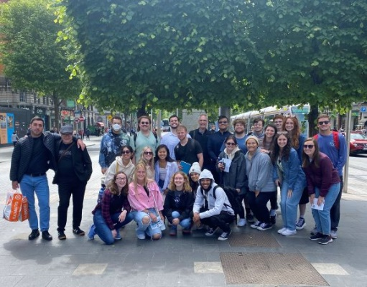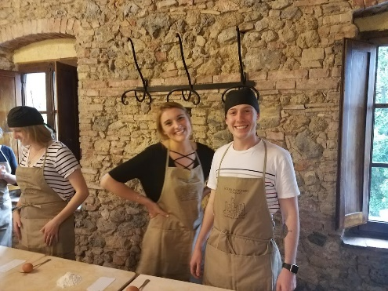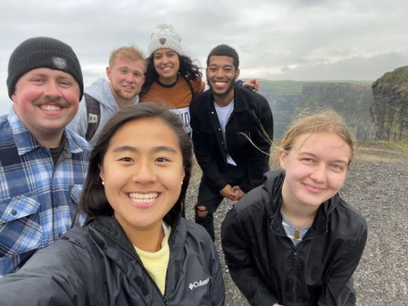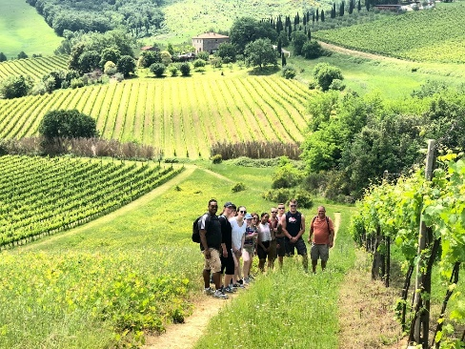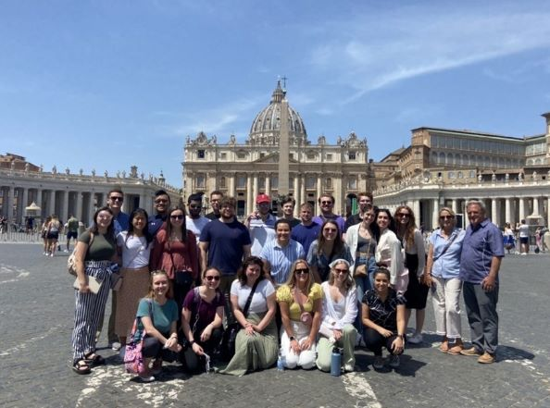
All majors welcome! 6 credits
Contact Dr. Sally Brasher sbrasher@shepherd.edu
To apply: https://ship.co1.qualtrics.com/jfe/form/SV_6fCiSCbevzXK4aq
or QR Code


