 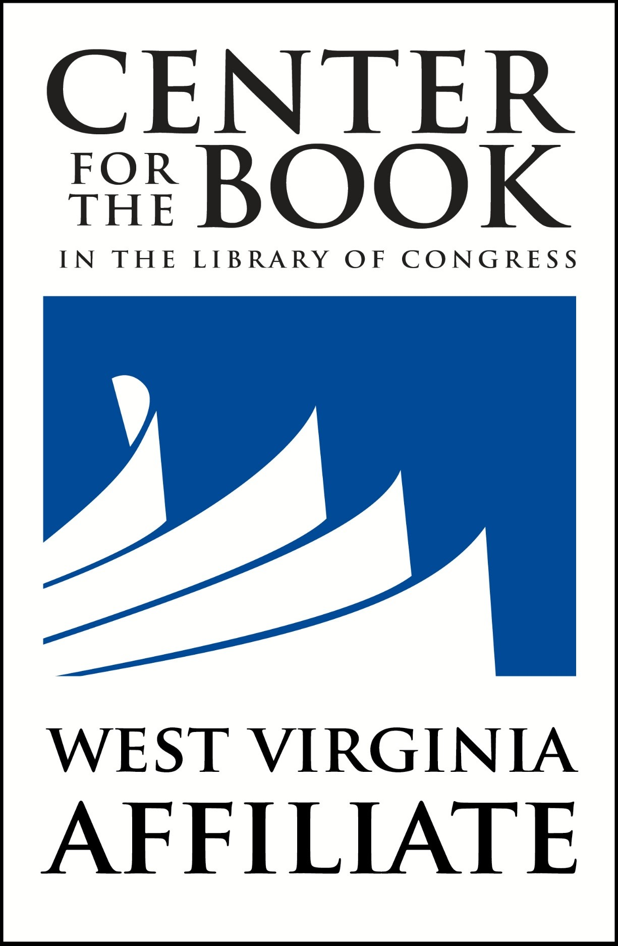 West Virginia Fiction Competition

Shepherd University’s Appalachian Heritage Writer-in-Residence (AHWIR) Project and the WV Center for the Book announce the 2023 West Virginia Fiction Competition, a literary competition to encourage writers and storytellers, whose talent and ability in creative writing is distinctive and promising, and to foster an appreciation of Appalachian people culture and values represented in the diverse writing of the region. Submissions are encouraged from any resident of West Virginia or student in West Virginia who meets the criteria below. Click here to view a list of past Fiction Competition winners.
Who can submit? Any resident of West Virginia or student attending school in West Virginia.
What are the limitations upon submissions? Any original, unpublished work of fiction, 5,000 word maximum, double spaced, one submission only. Submission may not have received any other award, recognition, or special honor.
What is the deadline for submissions? May 1, 2023
Where should submissions be mailed?
Electronic submissions should be sent to sshurbut@shepherd.edu.
What should accompany submissions? The application form below.
What prize will be awarded? $500.00 First Prize Award and possible publication, $100 each for Second Place, Third Place, and Judges’ Choice Awards for high school and middle school students.
Who will select the fiction contest winner? A panel of writers, editors, and creative writing instructors will choose finalists, and the 2023 Appalachian Heritage Writer-in-Residence (AHWIR) Ann Pancake will select winners from these finalists. The Fiction Prizes are funded by the West Virginia Center for the Book and will be presented by Ann Pancake on the night of Thursday, September 28, 2023, at Shepherd University, Robert Byrd CHE. Pancake will also provide reviews for each finalist’s story. The WV Fiction Competition is part of the 2023 AHWIR Project and Ann Pancake residency supported by the WV Humanities Council: “Appalachia and the Natural World, The Natural World and Appalachia: The Art of Ann Pancake.” Pancake’s award-winning novel Strange as This Weather Has Been will be the 2023 One Book One West Virginia Common Read. Fiction Competition winners will dine with Ann Pancake on the evening of the awards. All finalist and judges’ choice stories will be considered for the Anthology of Appalachian Writers, Ann Pancake Volume XVI.
When will the winners be notified? August 1, 2023
West Virginia Fiction Competition Submission Name:______________________________________________________________________________________ Title of Submission: ___________________________________________________________________________ Address: ____________________________________________________________________________________ E-mail: _________________________________________Phone: ______________________________________ Brief Bio. (100 word limit—include school affiliation/teacher if appropriate)

