**APPENDIX E: OPTIONAL RESIDENCE HALL RENOVATION OR REPLACEMENT INFORMATION**

1. **Program Overview**

The University is willing to allow Developers to provide proposals that include the delivery of renovated / replacement housing in addition to the development of the Project. The residence halls available for consideration are the East Campus Residence Halls in Gardiner Hall (118 beds), Kenamond Hall (156 beds), and Turner Hall (148 beds).

* **Total Shepherd Housing Inventory – 1,301 Beds**



1. **Replacement Housing Opportunity Goals and Objectives**

Through the delivery of the renovated / replacement beds, the University aims to achieve the following objectives:

* Shepherd’s overall housing capacity will not be reduced at any time in the execution of the replacement of the East Campus residence halls below the current 1,301 beds.
* The schedule for the renovation / replacement of the East Campus Residence Halls must be developed in collaboration with the University in order to ensure that existing bond covenants are maintained.
* The University recognizes that Renovated / Replacement Housing under a public-private partnership structure of some type would have some impact on the cash flow of Shepherd’s housing auxiliary. Shepherd will not proceed with that optional project under a public private partnership structure if doing so would reduce Shepherd’s debt coverage ratio substantially below what it would have been if Shepherd developed the same replacements and renovations on its own, as currently anticipated under Shepherd’s Campus Master Plan.
* The Renovated / Replacement Housing must be financially self-sustainable without additional subsidy from the University.
* Maintain existing Shepherd campus standards and consistency with the Campus Master Plan.
* Provide amenities and spaces that support the mission of on-campus housing.

1. **Housing Site Map**

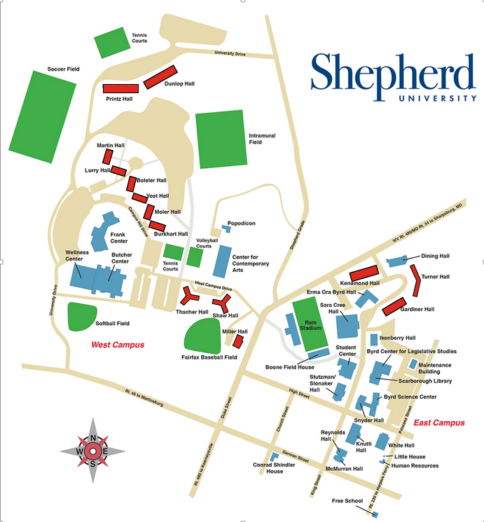

1. **Rental Rates for Renovated / Replacement Housing**

Developers are required to assume that rental rates will be competitive with similar housing provided Shepherd’s campus.

1. **Renovated / Replacement Housing Submission Materials**

In response to the Renovated / Replacement Housing, Developers are expected to address the following in Tab 8 of the proposal:

* Please indicate if there is interest in pursuing the Renovated / Replacement Housing according to the terms outlined herein
* If interested in the Renovated / Replacement Housing, please provide an indication of the deal structures that would be available for the University’s consideration
* Please indicate any potential challenges that may exist in utilizing the targeted deal structures given the requirements / objectives outlined in the RFP
* Please provide narrative on why you believe the proposed deal structures would be advantageous for the University to consider
* Please provide pertinent examples, if available, of when utilization of the targeted deal structures have been previously utilized to address the replacement or renovation of existing on-campus housing