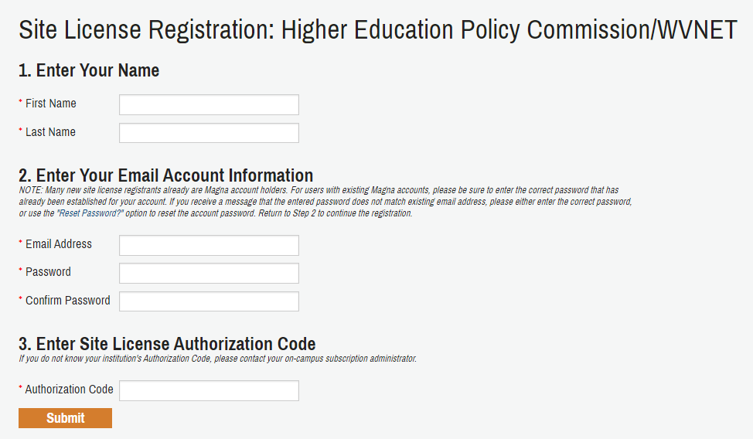

**STEP 1: Activate your Magna Commons subscription**

1.       Go to [www.magnapubs.com/sitelicense/registration.html?v=magna271](http://www.magnapubs.com/sitelicense/registration.html?v=magna271)

2.       Enter information in each of the required fields.  In the Authorization Code box, enter the group Authorization Code **WVNET212** and click Submit

*Please note: entering the Authorization Code is done only once.*

**STEP 2: Access the Magna Commons library**

1.          Go to [www.magnapubs.com/profile](http://www.magnapubs.com/profile)

2.          Enter your email address & password & click Submit. If you do not know or remember your account password, use “Forgot your password?” to reset it.

3.          On the left side of the screen, under My Account, My Online Access, select Subscriptions. The online content you have access to will be listed to the right. Click the appropriate link to view the content.