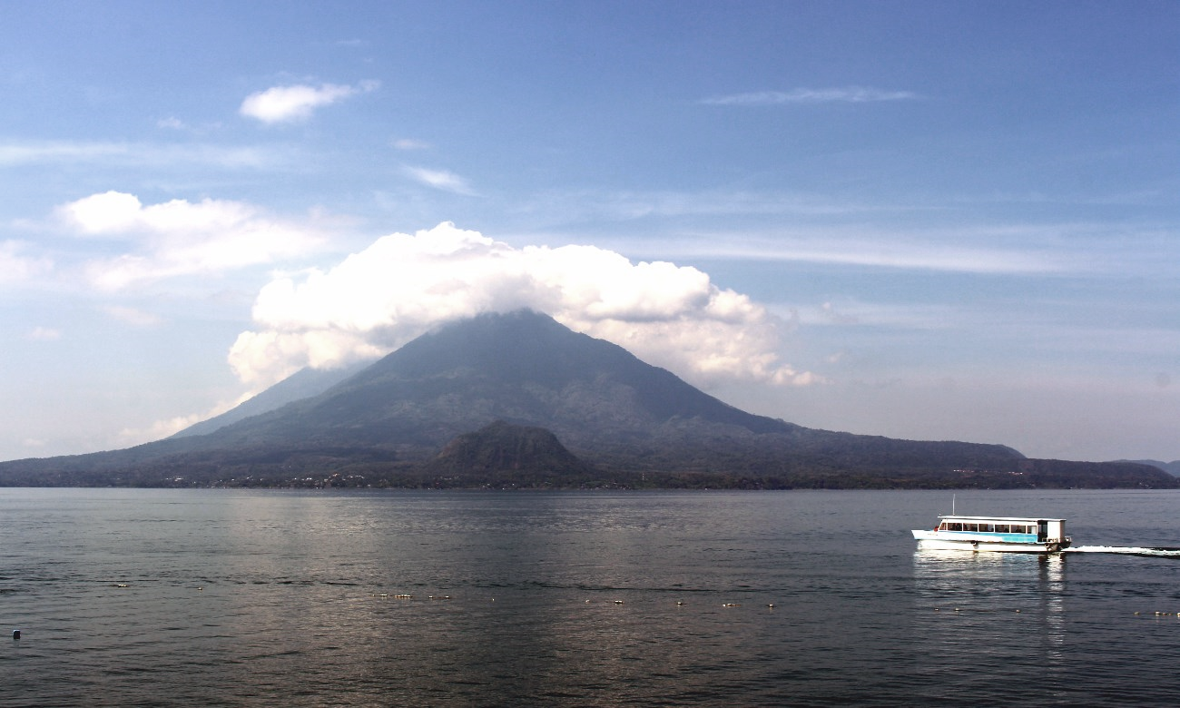
Global Shepherd
In & Out

In this volume, we want to highlight study abroad. This year 104 Shepherd students traveled to 19 international destinations in a diverse array of programs. As a sampler, we have selected several students whose stories are particularly interesting. Among them are two students whom we introduced in our first newsletter and now return to share their experiences with you as they finish their semester abroad (Adam Hull, who is back from his biomedical research internship in Puebla, Mexico; and Tamar Tipton who is still in China).

We also want to acknowledge our faculty members, who alongside their teaching load, have led study abroad trips that connect our campus community to people, places, and universities far away. These are our global guides, opening new cultural doors for our students and helping expand their horizons and see a world of possibilities for their future. Of special note are the following who have led trips in the spring and summer terms:
- Denis Berenschott:
  - Cuba: Culture and Social Policy (co-leader) (Spring Break)
  - Costa Rica: Spaning Immersion (Summer)
- Sally Brasher: Multiple European countries: Evolution of European Government and Society (Summer)
- Amy Garzón Hampton:
  - Cuba: Culture and Social Policy (co-leader) (Spring break)
  - Mexico: International Community Service Learning (Summer)
- Rob Tudor: Music in Portugal and Spain (Summer)

This volume is also a bittersweet opportunity for Charles as he bids farewell and enters retirement on July 1. “While it is certainly a very exciting time for me with many new potential callings, I will miss the students, faculty and staff who make this university the special place it is. It has been a privilege and honor to serve at Shepherd, and I am very grateful for the support and partnership over the past years.” He would also like to say a special “thank you” to our community members (Global Connectors) who have done so much to support international students and to help them truly experience a “home away from home.”

Most of all, though, we would like to extend a sincere “thank you” to the McMillan family for its generous support of Shepherd’s international programs. It has truly been transformational.

Charles Nieman Yin Star

Director, International Affairs Director of Study Abroad

http://www.shepherd.edu/global http://www.shepherd.edu/study-abroad

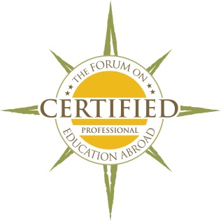
Congratulations, Yin!
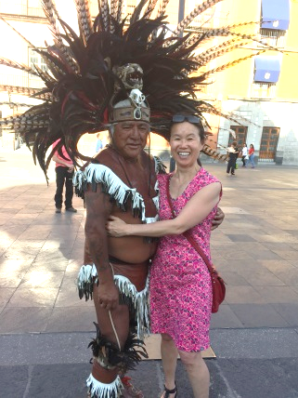
Over the past 18 months, Yin has participated in a rigorous training program offered through the Forum on Education Abroad, the premier organization for study abroad professionals, and has now earned her certification. With this, she joins an elite group of only 46 Certified Professionals in Education Abroad within US higher education.
This comprehensive training program has prepared Yin to effectively articulate and apply the Standards of Good Practice for Education Abroad as she continues to form a best-practice office for Shepherd. Included are six modules, each with associated workshops and assignments, and a culminating project. All are challenging and designed to have practical application in a participant’s current and future positions. As she progressed through the modules, her work was assessed by trained Forum Certification Assessors with 10 or more years of experience in the field and more than five years of senior level experience.
Certified Professionals are recognized on The Forum’s website, receive a digital badge describing the skills demonstrated by the certification and are recognized at The Forum’s annual conference.
This is a significant achievement for Yin and an important national recognition for Shepherd University.

Students, in their own words…

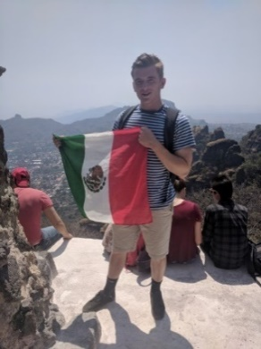
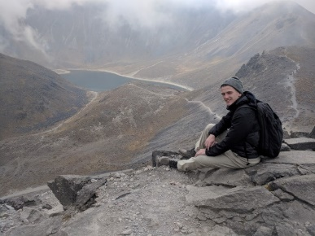
Adam Hull a senior, biology major and chemistry minor, travelled to Puebla, Mexico in January to begin a semester long biomedical research internship at Universidad Popular Autónoma del Estado de Puebla, (UPAEP). Reflecting on his time, Adam notes, “I’ll leave Mexico with more than just laboratory knowledge that will help me in medical school. I have learned how to integrate into, appreciate, and understand another culture, a crucial skill as patient interaction is one of the cornerstones of practicing medicine, and patients are not from homogenous backgrounds. Furthermore, I’ve never been more confident in my speaking and understanding of the Spanish language. This is an objective skill that I’ve already used in the past, but now I’ll be able to communicate more effectively. Finally, Mexicans emphasize certain values that are sometimes overlooked in other parts of the world, like appreciating time together, manners, and a warming hospitality. I have seen the importance of these values and will integrate them into my training and practice in order to be a more effective doctor.”
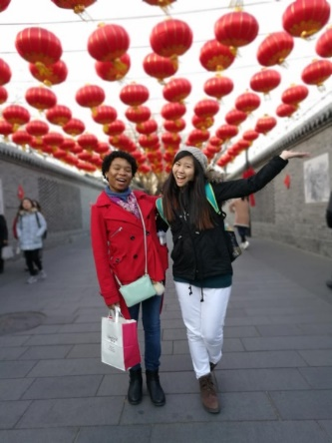
Tamar-Marie Tipton, a junior and music major, travelled to China in late February to study abroad in Beijing through our partner provider, KEI. The program ends on June 30. She talks about her experience in China so far:
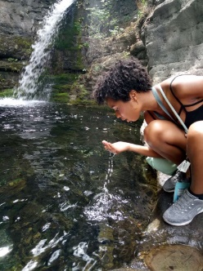
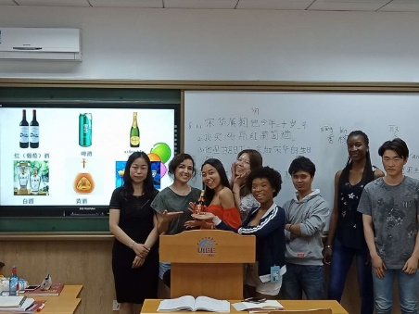
“It has been a little over two months since I landed in Beijing, China: a land that I had dreamed to visit for three years. I was incredibly excited upon my initial arrival, but the culture shock that I underwent quickly diminished any hope that I would enjoy the rest of my time here. For two weeks straight all I could think of was going home and missing my family and friends. Little simple things that I had taken for granted back home, like being able to clearly articulate what food I wanted in a restaurant, or being able to have drinkable running water, seemed to be such luxuries here. Hope seemed lost, but slowly, a miracle was bestowed upon me: Time. Time passed, more time passed, and after that even more time passed. Slowly I was able to pick up things in my Chinese classes that I could use in my local life. Slowly I got used to having to buy a gallon of water every two weeks. I got used to having a single drain next to my toilet being called my shower. I pushed myself out of my comfort zone and met incredible people and after two months I am elated to be able to say that I view China as a home away from home. The teachers that I have here have been nothing short of amazing. I have three teachers, each for a specific area. Because of the reputation China has in the States, I thought the classes would be very strict and rigorous. Rigorous, they are, but the teachers teach in a way that creates a safe environment and encourages my peers and me to learn more outside of the books.
Fortunately, I was able to be in a program that included trips in the program fee. So I’ve been to a couple of other cities like Xi’an and Shanghai. Both of those experiences were amazing, most notably, visiting the Terracotta Army and Shanghai Disneyland. My roommate and I have gone on mini trips to places around Beijing and surrounding areas that have been as rewarding as venturing out to other big cities. Three hours away from our home campus is a place called Shidu Mountain. It’s a beautiful landscape that you’re able to climb and explore and it has a number of waterfalls. We were also able to go Bamboo Rafting, which is something that I hadn’t even heard of before coming to China.
All of these things I have mentioned have been a great part of my experience, but the thing that makes China feel like home has been the people I have met. Whether it is from my dorm, my classroom, or from small events that I’ve attended from WeChat groups, I have met some of the most genuine, kind and caring people I have ever met in my life. I have a Chinese friend who spent a year in Mexico and speaks fluent Spanish. His English is not that great, but it’s actually beneficial for me because it helps me to practice my Spanish. Anytime I’m out with him and others, I find myself speaking three languages at any given time, something that is unheard of in the States. The feeling I get from this is like no other and I will keep dear to my heart. This is why I’ve decided to explore opportunities to complete a master’s degree abroad. I’m not sure where exactly or what the future holds for me, but I know that coming to China, even just for these few two months has completely changed my life and I’m so happy to have been able to experience it.”
Crystal Brooks, a senior art major writes: “This summer, for the fourth time, I’ll be returning to the country that has held my fascination for as long as I can remember: Japan. To further advance my knowledge of the language and culture, I’ve enrolled into a Japanese Language school called KCP International. For 2 months I’ll be residing in Yokohama and commuting up to Shinjuku to study. My ambition is to have this intensive language program give me the boost I need to become more fluent. I’ve been planning to start my artistic career abroad in Tokyo or Osaka and to do so I’ll need to be proficient in conversation and to be able to communicate like a local in reading and writing. Because my goal is to live and work in a foreign country, I need as much immersion as possible. The skills I need are difficult to glean from a classroom alone.
On my journey to language proficiency, I studied abroad in Akita through Shepherd’s Partner provider, KEI, for 4 months last spring. This trip brought with it so many first-hand experiences with the language and the culture that I will never forget, particularly regarding social interactions in Japan. This is stuff you can’t fully comprehend from reading a textbook. I made a lot of great friends and inspired others while there, so despite the cost, it all was worth it. Somehow, I even found myself while abroad, by developing a stronger sense of self in overcoming all sorts of obstacles that people back home would shy away from. I wouldn’t trade that experience for anything. So now, I look forward to what this trip holds for me, because I know that each time I have the privilege to go abroad, something amazing happens. The adventure is what draws me in and the deeply fulfilling rewards keep me coming back.
I am also pursuing attendance to my dream school, Temple University’s Japan Campus. Thank you for taking time to read my journey this far, I don’t know what the future holds for me but I do know it will be something great from all the risks I take to move forward towards my dream.”

Emily Foote, a junior majoring in data analytics, and Shaylin Post, a junior majoring in Engineering Science with a concentration in environmental science, will be travelling to Turin, Italy for the European Innovation Academy (EIA) from July 5-29. Participation in the Academy is by invitation, and this is the second year that students selected by Shepherd’s CME Department will be attending. The EIA is a world-class entrepreneurship program that gives selected students from all over the world the opportunity to meet with and learn from some of the biggest leaders in the tech industry. Students, grouped in to teams of 5, are tasked with the development of an innovative startup and, with the help of industry and academic mentors, see it through to the marketing phase and presentation to potential investors.
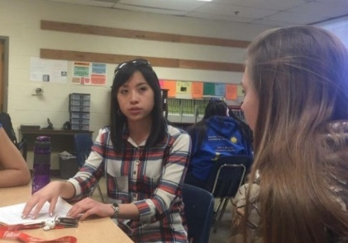
Emily talks about why she is going, what she hopes to gain and the impact of EIA in her goals and future. “Since my freshman year of college, I have wanted to study abroad. However, not many programs are offered in my major or in my concentration in big data. One day, my data professor told me that the chair of the CME department was looking for two people to send to Italy, and I have been sold since the moment he said “Italy.” I hope to learn more about new technology, how to keep up to date with the growing industry, and how to network with individuals of higher qualification or status. I also want to open my mind to the world and learn more about a culture so different from ours. EIA will be my first experience in technology and entrepreneurship. As of now, I am uncertain where my degree in data analytics will take me. I hope that this opportunity will help me better understand my role in society and solidify my confidence in my own future.”
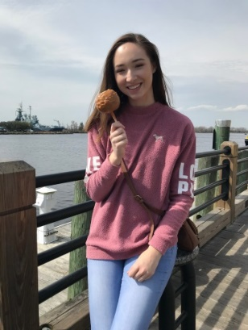
Shaylin looks forward to the opportunity to work with students from different cultures and backgrounds using the knowledge she has obtained from Shepherd. “I also look forward to some sight-seeing in Italy and experiencing their culture. I have never travelled outside of the United States, so getting to see a new country will be an awesome adventure. I hope to gain confidence in the material I have been taught after going to Italy. It will be helpful to see how working together with people that have other skills and interests can accomplish something and how my skill sets fit in and are useful.”

Spencer Vanhoose, a senior and Political Science major, is currently in Ottawa, Canada participating in the Canadian Parliamentary Internship that is facilitated by the Political Science Department at Shepherd.

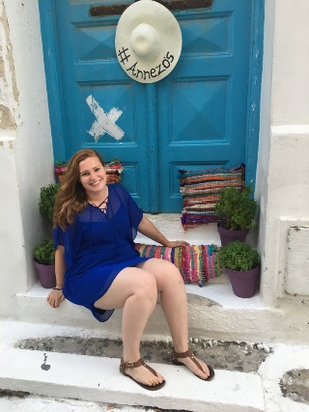
Michelle Reid graduated from Shepherd in May with a degree in Global Studies and a minor in Geography/Anthropology. While at Shepherd, she participated in the month-long study abroad program with the art department, “The Art of Europe”. “This study abroad trip was one of my most memorable experiences as an undergrad at Shepherd and contributed to my decision on what the next steps would be after graduation.”
Michelle has been accepted to George Washington University for graduate school, but she has chosen to do a gap year with the Teaching Assistant Program in France, teaching English to primary school students in the region of Versailles, a small suburb outside of Paris. She explains, “After completing my study abroad program during the summer of 2017, I began looking into opportunities that would allow me to go abroad for a substantial period of time. Through my research, I came across the Teaching Assistant Program in France and I decided that this would be the perfect opportunity to gain more experience abroad, while helping others. The program runs for seven months, from the beginning of October through the end of April. I believe that this experience will contribute to my future career goals, since it will allow me to expand my intercultural competence and become fluent in another language. I also plan to volunteer at an international NGO while I’m there to gain more experience working in the international arena. After completing this program, I will be attending George Washington University for an M.A. in International Affairs with a concentration in Global Energy and Environmental Policy. In my future career, I would like to work in the public or nonprofit sector, working on international initiatives that will protect wildlife to help minimize the illegal wildlife trade.”

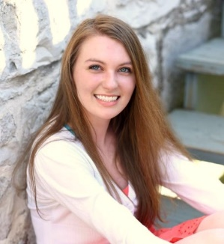
Sarah Dillow, a senior, double majoring in accounting and economics, will be studying this summer at Hanyang University in Seoul, South Korea, through our partner provider ISA. In looking forward to this time, she notes, “Since Seoul is the largest metropolis in South Korea, I won’t only be communicating with students and professors that I will be facing on a daily basis at the university, but also with the individuals that make up the community. Being involved in the community and the university will allow me to expand my network and collaborate with other students and professors who will be going into or who are in my field of study. Independence, interpersonal communication, and adaptability are some of the most crucial skills for becoming a leader in society and in my own life. These skills will allow me to become more confident in my abilities and allow myself to take on leadership positions that I wouldn’t otherwise take. Overcoming the obstacles that I must face during my study abroad experience will not only change my perspective on the topics that I learn in my majors, but also the outlook on the world that I carry with me every day. I will be able to take part in a different culture as well as seeing my own culture through a different perspective. This can help me develop my own perspective on issues in my own country as well as on a global level than having the perspective that I was raised with and the views that are present in my own community.”

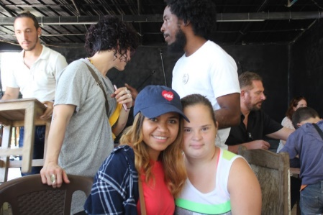
Deta Kolo-Johnson, junior and Accounting major, is from the small island nation of East-Timor, which is in Southeast Asia. Over spring break, Deta travelled to Cuba with Amy Garzón Hampton from the Department of Social Work as part of the course Cuba: Culture and Social Policy. While there, she took classes at the University of Havana and volunteered at several organizations, including Muraleando, which is a community art project organization that is an after-school program offered for kids to learn about different types of art. Deta reflected, “One of my favorite things we did in Cuba was getting a tour of what a typical family home looked like. A normal-sized family home consisted of two bedrooms, a living room, kitchen and a small bathroom. This was an interesting experience for me, because the home that we toured was probably not much bigger than a single room in Potomac Place. I was amazed at how neat these homes were despite not having much space to put anything. This experience made me realize that half of the things I own at home are unnecessary. I had such a fun experience in Cuba that I recruited 12 family and friends to go back with me this summer.”

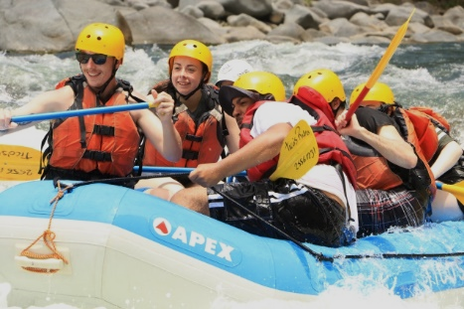
Lindsay Williams, a junior and Chemistry major, travelled to Costa Rica with Dr. Denis Berenschot on the Spanish Immersion Program in May. Lindsay said “I went to Costa Rica to build upon my Spanish language skills and to explore a new part of the world. In Costa Rica I was not only able to learn about the culture, but I was also able to break out of my comfort zone and become more independent. My favorite part of the trip was rafting down the Pacuare River with my fellow classmates. This trip has helped to improve my Spanish language skills which will help me when I become a pharmacist in the future.”

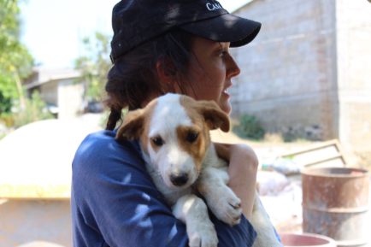
Cecilia Bettendorf, a junior majoring in Social Work, went on the International Community Service Learning trip to Puebla, Mexico in May with Amy Garzón Hampton. She said “I wanted to experience a different culture and see their needs as people. I got to witness the human experience in all forms: from listening to women in prison; speaking to volunteers at a migrant house for refugees; to spending 3 days in the mountains building houses for earthquake victims. Not only did we volunteer, but also we got to experience the beautiful nature of Mexico while we trekked and crawled through underground caves of Cuetzalan. From this trip I gained so much insight into different kinds of people and into using empathy. It will help me in my future career by drawing from my experiences with people in Mexico.”

Study Abroad Office Programs and Outreach
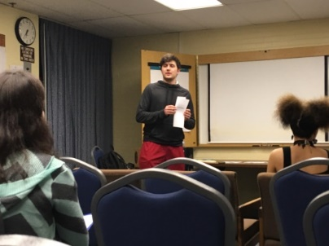
Programs
Preparation Workshops: The Study Abroad Club sponsored three workshops to help interested students better prepare for successful study abroad. Under the program title of “Are you Ready to Seek your Study Abroad Adventure?” the workshops covered: (a) How to Get Started; (b) Funding Your Experience; and (c) Pre-Departure, Applying, Preparing, and Leaving. Danielle Duvall, Financial Aid Counselor, provided information on funding and financial aid and on the critical need to long-term plan and wisely leverage available resources. Thank you, Danielle! Students who studied abroad provided testimonies and guided the conversation.
Honoring graduates who have studied abroad: In early April, graduating students who had studied abroad were honored and presented with a blue and gold cord for their commencement gowns. As part of the ceremony, the graduates were also invited to speak about their experiences and share photos.

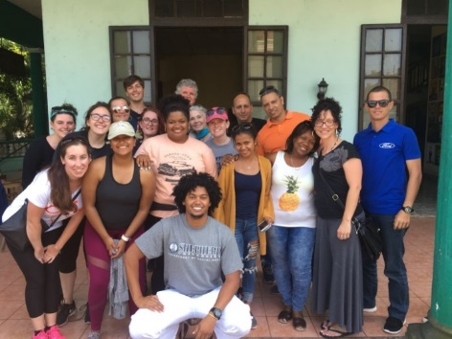
Havana Night: A group of 10 students traveled to Cuba in March with Amy Garzón Hampton from the Department of Social Work as part of the course Cuba: Culture and Social Policy. Upon their return, the students teamed up with the Study Abroad Club to present Havana Night as a way to share some of their experiences with the campus and local community. Included were student presentations and reflections from the course, a sampling of Cuban food, Cuban salsa lessons, a silent auction of artisan jewelry and other items from the island, and videos showcasing their time in Havana. The night was an incredible success with 70 people attending. We want to give a BIG shout out and HUGE thanks to Amy for her role in leading the trip and in contributing to the success of the night and to Rhonda Smith for providing the use of Room 112 in the Center for Contemporary Art, since the weather was not cooperating for and outside event as intended. Also HUGE thanks go to IT Services, in particular Jennie Khun and Andrew Ford, for ensuring that the audio/visual systems ran smoothly, and to Debbie Langford-Hiergeist and Bea Stottlemyer for their help in ensuring that everything went well on the financial front for Amy to travel to Cuba with the students.
Outreach: Throughout this year, Yin spoke to 37 classes, reaching 397 students, many of whom were part of the FYEX group, to encourage study abroad and to help students plan wisely. Scholarship opportunities and financial aid were also covered, and students who had already studied abroad shared their experiences and showed photos. Then the students were asked to complete a very brief interest survey, the results of which are available at FYEX Chart_17-18.docx . In addition to the class presentations, 22 students met individually with Yin, discussing options and preparations. Together, these attest to a growing interest in accessing study abroad and building international study into degree programs. Immense thanks to the faculty and staff who gave Yin the time to speak in their classes. And grateful thanks are sent to Liz Samandasuk and Noelle Kesner for their work in the Study Abroad Office.

Visiting Scholars

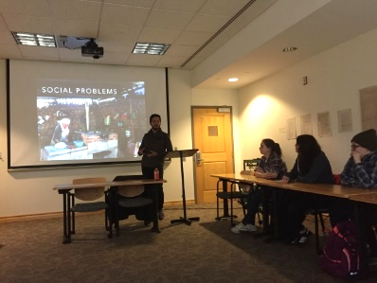
“Pepe” Cernicchiaro Guadarrama, Coordinator of Social Commitment at Anáhuac University, Puebla, Mexico, visited Shepherd in late January to continue the collaboration with Amy Garzón Hampton begun last summer. While here, he attended lectures, presented to students and faculty about his work and participated in two workshops on international human rights. Anáhuac University is a partner institution to Shepherd. In May, Amy led a group of students to Puebla on a study abroad trip that focused on International Community Service Learning.

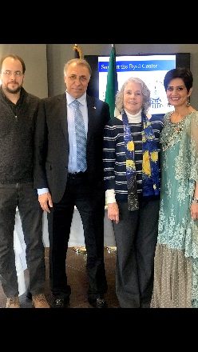

Dr. Abdulwahab Al Dhafiri, Kuwait University, is a visiting faculty member in the Department of Social Work. He is spending his sabbatical at Shepherd University doing research in social policy. In addition to his research activities, he and his wife presented a program on Kuwait during International Culture Week. Following the program, attendees were treated to a variety of Kuwaiti foods and beverages.

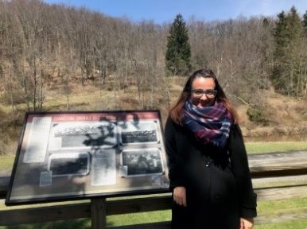
Dr. Laura Martinez Garcia, COIL (Collaborative Online International Learning) Coordinator and faculty member in the Department of Linguistics, English, French and German at Oviedo University, Spain visited Shepherd University to meet with faculty, staff and students. The University of Oviedo was founded in 1608 and is now a research university offering an array of undergraduate, master and doctoral degree programs. Many of these are offered bilingually in Spanish and English. Also, Oviedo offers a Spanish immersion program for international students. The visit was arranged in partnership with Dr. Megan Gibbons, Glenville State University.

Three broad areas were discussed during her visit, which we hope will evolve into a multi-level and multi-disciplinary partnership:

- Appalachian Studies: The state of Asturias, in which the University of Oviedo sits, has historic ties to Appalachia, and in particular to the Clarksburg, WV, area and its coal and zinc mines. Although the mines and mills have largely closed, Asturian pockets remain with many retaining the language and culture of their Spanish origin. An exchange program would potentially support bilateral movement and study abroad at the graduate and undergraduate levels, encourage faculty research collaboration, and contribute to the development of an international degree program in Appalachian Studies.

- COIL: COIL at Oviedo is relatively new, but is considered as a promising initiative. Their work thus far utilizes Zoom as one of the instructional platforms, which interfaces well at Shepherd. Potential areas of collaboration are in Appalachian Studies, Art History, Communication Studies, History, Psychology, Social Work, Sociology, and Spanish.

- Study Abroad: Oviedo offers many positives as a destination and regional portal for study abroad and exchange. As we talked about the opportunities, a strong recommendation for a student exchange agreement emerged that would allow participating students to pay tuition at the home university. This certainly would ease issues with financial aid and course credits. In addition, the bilingual graduate degree programs offer exciting options for our students to consider Oviedo for their Masters.

Ambassadorial Visit

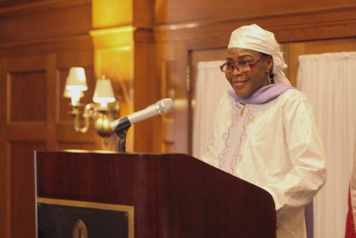
On April 12, Shepherd University hosted the ambassador to the United States from Niger, Hassana Alidou. The Department of Political Science and Global Studies, Pi Sigma Alpha, the political science honor society, and Phi Beta Delta, the honor society for international scholar, sponsored the visit.
The Ambassador spoke about Niger’s economic system, political structures, and cultural traditions. Please see the news release for further details.

New and Pending Institutional Partners
(*current list of partners)

College of Micronesia, Federated States of Micronesia (Student Exchange and 2+2 for Business and
Computer Information Systems pending)
Graduate School of Interdisciplinary Science and Engineering in Health Systems, Okayama
University, Japan (pending)
School and Faculty of Medicine, Tsukuba University, Japan (pending)
University of Oviedo, Oviedo, Spain (pending)

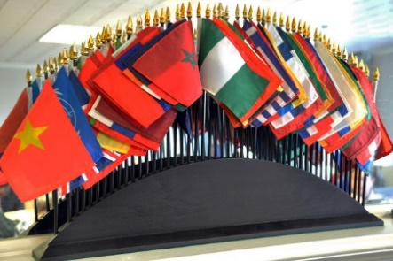
(http://www.shepherd.edu/global)

*Additional international program updates also available for: Intensive English Language Program, Phi Beta Delta; Pi Sigma Alpha; and Model UN

