Global Shepherd
In & Out

Welcome to our inaugural volume of Global Shepherd, In and Out! In it you we introduce you to some of our amazing students, faculty, and partners who are crossing boundaries and connecting us to people, places, and universities far away. Our hope is that their stories will inform, encourage, and inspire. We are also providing brief updates on related programs and initiatives supporting internationalization.

I would like to thank Yin Star, Director of Study Abroad, and her team of student reporters for their work in creating this newsletter.

Charles Nieman

Director, International Affairs

http://www.shepherd.edu/global

Students

This fall we welcomed 18 international students representing 14 nationalities. Four entered graduate studies (MBA and MSDAIS). Two undergraduates (Imen Bouhestine, Tunisia, and Adnan Haider, Pakistan) are exchange students who won prestigious scholarships administered by IREX on behalf of the US Department of State, and one of our new freshmen is the daughter of a Shepherd alumnus (Cristina Fal Conde Tapia, whose father, Javier Fal-Conde, graduated in 1992)! Fall international student enrollment totals 31 and the trend is modest growth.
As the summer drew to a close, so too did last year’s study abroad trips. Over 100 students went abroad on a variety of programs—a significant increase over the previous year. Among them were those who took paths less traveled--Cuba, Finland, and Japan.
Following are short introductions to four students. One is an international exchange student, one is heading off for a research internship in Mexico, one is leaving to study Chinese, and the last will attend graduate school in Scotland in a new joint degree program.

Imen Bouhestine – Interview provided by Noelle Kesner
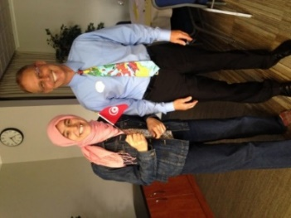
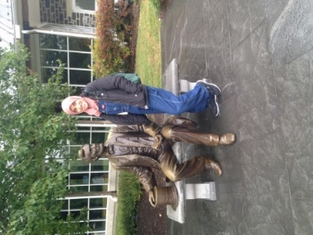
Imen Bouhestine is a Tunisian exchange student currently studying Global Studies at Shepherd. Imen is a recipient of the Thomas Jefferson Scholarship Program through the International Research & Exchange organization (IREX). IREX was created in 1968, with the intention of fostering professional and academic exchanges. It supports people trying to drive educational reform and building accountable governance. The Thomas Jefferson Scholarship Program, sponsored by the Department of State and administered by IREX is specifically dedicated for Tunisian students in order to empower them as global citizens contributing to the development of Tunisia. She will spend another year at her university in Tunisia and graduate spring 2019 as most her Global Studies credits will not transfer to her major in Finance. This, however, does not seem to deter Imen, who sees her biggest challenge as exploring the American culture while doing great in school and being active. She loves being at Shepherd, has participated in Model UN and Debate & Forensics tournaments and knows most of the lyrics of “Country Roads Take me home”.

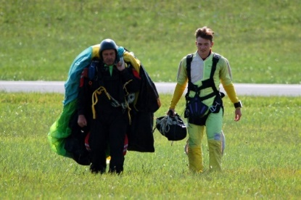
Adam Hull, a senior biology major and chemistry minor, will travel to Puebla, Mexico in January to begin his semester-long biomedical internship at Universidad Popular Autónoma del Estado de Puebla, (UPAEP). Since the beginning of his undergraduate study, he has wanted to study abroad; however, within his major certain classes are offered chronologically and a missed semester would potentially set him behind the normal course progression. Despite this, he continued searching for opportunities to travel, especially to Central or South America to utilize and improve his Spanish skills.

“I want to go to UPAEP because of its ability to give me a cultural experience of living in another country, along with being able to provide me with the opportunity of gaining more experience in a large, laboratory setting. Shepherd University, through its affiliation with West Virginia University, has had students who previously studied abroad at UPAEP. I worked extensively with the Study Abroad office at Shepherd to try to find this opportunity and fit it into my schedule. Studying at UPAEP for a semester would be the culmination of my undergraduate experience, and would provide me with international perspective and skills that would foster my success in the future. A semester at UPAEP would dramatically improve my Spanish speaking abilities, and would give me the confidence to communicate fluently. Furthermore, by learning about other cultures I will be able to approach future patient interactions with more poise.”

In the spring term, junior Tamar-Marie Tipton will be studying abroad in Beijing, China, in a Chinese language program arranged through Shepherd University’s partner provider, KEI.
Tamar is majoring in music. In middle school, she picked up the clarinet and she has been smitten with it ever since, often saying that she has known no love greater than that which music brings her. Through hard work and dedication, she got into the Peabody Preparatory program of Johns Hopkins University, on a full scholarship, and also won an audition at the Baltimore School for the Arts.
While at Shepherd, Tamar won an audition in the 2017 Air Force Band Collegiate Symposium and also became a member of the Tau Sigma honor society. She is also currently on track to win an audition with the United States Marine Band. She specifically chose to be a general music major because it combined the aspects of music she wanted, while also having a foreign language requirement. She took a semester of Chinese in her freshman year at Towson University, and felt that KEI was a good opportunity for her to learn the language. She said that “to become immersed in Mandarin is an inexplicable opportunity. I would love to be able to become fluent in Chinese and to be able travel there to teach English and Music. It would be a great way for me to be more flexible to the community around me and to also get to know people of different cultures and backgrounds”.
Sean Murtaugh, an MBA and retired Captain in the U.S. Coast Guard, is completing his Appalachian Studies Certificate this term. In January he will travel to Scotland for further study at Shepherd University’s new partner, the University of the West of Scotland (UWS). Coordinated by Dr. Sylvia Shurbutt, graduate students who complete the Appalachian Studies Certificate have an exciting opportunity to receive credit for the first module (semester) and apply that toward the MA in Creative Media at UWS. Following one semester at UWS, students return and complete their MA project with Dr. Shurbutt and their UWS graduate coordinator.
Sean has focused his work in Appalachian Studies on finding ways to enhance the economic growth and well-being of West Virginia, which has become his beloved adopted state. With an MA in Creative Media, he will be able to expand upon his work in this area and use these educational skills to develop professional level documents and media that focus on improving the health of West Virginia’s economy, particularly in the Eastern Panhandle region.
“I am very excited about this new opportunity and to be the first Shepherd graduate student to attend graduate courses at the University of the West of Scotland (UWS) next semester. This new exchange program between Shepherd University and UWS is an excellent opportunity for both universities to partner together, and to share our unique cultures, Scot-Irish roots, and academic strengths. I am hopeful that it will be the beginning of a strong program of international exchange programs between the students of both schools.”
Study Abroad
This year’s study abroad photo contest just closed and winners will be announced shortly. From the many photos, the following were featured and each included a brief explanatory or reflective narrative from the traveler. We hope you had a chance to read them as they moved across campus and vote!
- “Doors you come through”

- “Shepherd Rams pride abroad”
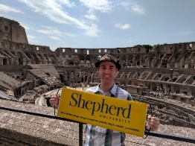

- “A moment that reflects your study abroad.”
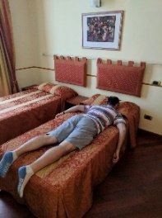

Upcoming Faculty Led Trips:
Cuba: Culture and Social Policy Amy Hampton (March 8 - March 17)
Music in Portugal and Spain Rob Tudor (May 5 - May 18)
Spanish Immersion: Costa Rica Denis Berenschot (May 6 - May 22)
Evolution of European Government and Society Sally Brasher (May 20 - June 14)

Study Abroad Officer from London South Bank University visits Shepherd
Malcolm Davidson, Study Abroad Officer from London South Bank University (LBSU) visited Shepherd University in early November with Ray Bates, KEI partner provider to WVHEPC. Malcolm spoke about his university and the programs and internships offered for our students either for a semester or a year, and he met with interested students. LBSU offers opportunities in a wide variety of disciplines. For more information, click here.
Capacity-building Grant period ends. On November 30, 2017, Shepherd University submitted its final report for one-time special grant funding provided by the U.S. Department of State to develop or enhance undergraduate study abroad. The award period stretched over 15 months and was valued at just under $50,000. Shepherd’s award was one of only 17 such grants offered nationally in the 2016 round, and at the conclusion of the grant period, Shepherd was featured as the grant program’s success story for the 2016 cohort. In September, Yin Star, Director of Study Abroad, was invited to speak at a Travel Bloggers Summit in NYC, sharing Shepherd’s success story. Please click here for further information.

The grant greatly accelerated the transformation of Shepherd’s part-time Study Abroad Office into full-time and comprehensive, with a professionally-certified director and expanded opportunities for study outside the United States. It also supported many new initiatives for study abroad, among which were providing travel funds for eight faculty members to either lead a trip to a new destination or to conduct a pre-trip coordinating visit for a future faculty-led study abroad. The disciplines represented were: Appalachian Studies, Computer Engineering, Family and Consumer Studies, Health and Exercise Science, Historic Preservation, Psychology, Social Work, and Spanish. It also supported Shepherd University’s first invited participation in the Extreme Entrepreneurship Program, offered through the European Innovation Academy in Turin, Italy.

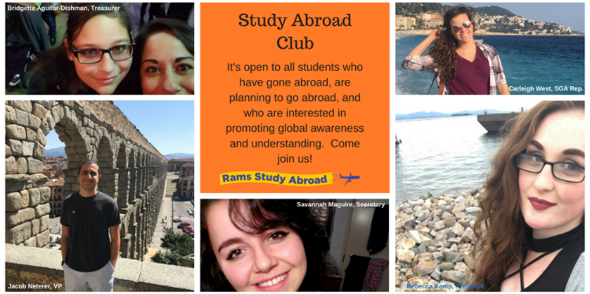
The Study Abroad Club meets every week on Thursday at 5-6 pm. Rebecca Kamp is at the helm as President; Jacob Neterer, VP; Savannah Maguire, Secretary; Bridgette Aguilar-Dishman, Treasurer, and Carleigh West is the club’s SGA Representative. At club meetings, students who have studied abroad have spoken about their experience and international students have come to speak about their culture and countries. Kayla Turner, a graduate student in the CSDA program, also spoke about her experience teaching English in Japan through the Japan Exchange and Teaching (JET) Program.

The Study Abroad Club sponsored a workshop on “How to Get Started on the Study Abroad Process” on November 30. This was the first in a series designed to help prospective travelers efficiently plan for their study abroad. Other upcoming sessions include “Funding Your Experience” (January 18) and “Pre-Departure, Applying, Preparing, and Leaving” (February 15)—both will be held in the Potomac Room, beginning at 6:30 PM. Watch Ram Pulse for other events and programs, and for questions, please contact Rebecca Kamp at RKAMP01@rams.shepherd.edu.

Thank you, instructors! Throughout this fall, Yin Star spoke to 37 classes on Study Abroad, many of which were FYEX. She passes on “Huge thanks” to the faculty and staff who gave her the time to speak in their classes. While with the classes, she also asked students to dream and list countries they would be interested in for study abroad. Yin will be consolidating the results for planning future trips and sharing with instructors.

Global Studies

Global Studies is in its fourth semester as a new degree program and in spring will have its first capstone students (and hopefully graduates)!

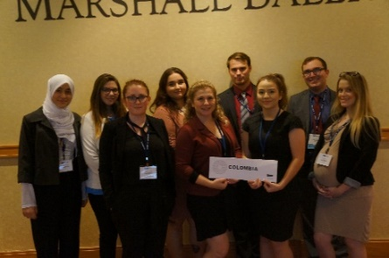
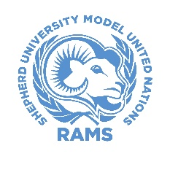
The Model UN team is increasingly successful in regional competition and most recently participated in the National Model UN Conference held in Washington, DC, joining 900 students from 67 universities around the world. The team represented Colombia. The next competition is the Southern Regional that will be held in Charlotte, NC in April, at which time the team will represent Algeria and Switzerland.

The BIG news, though, is that Shepherd’s Model UN Program is the recipient of one of this year’s WISH Grants. The award totals $26,000 and provides critical funding over the next three years to support conference registrations and travel for Shepherd’s team. The Grant will also support a High School Model UN conference to be organized by the Shepherd team and held late next spring or early summer. High school teams from the four-state area will be invited to campus for the competition and, of course, an introduction to Shepherd University. For more information, please contact Dr. Aart Holtslag.

Visiting Scholars

It is an honor to announce three visiting scholars in the spring term. A special “Thank you” goes out to Dr. Geri Crawley-Woods and the Department of Social Work for their support in serving as the host department!

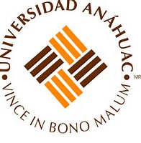
- Georgina Ruiz Toledo is the Coordinator of the Center of Research and “Pepe” Cernicchiaro Guadarrama is the Coordinator of Social Commitment at Anáhuac University, Puebla, Mexico. Both will be at Shepherd for two weeks in January to continue the collaboration with Amy Garzón Hampton they had begun last summer. While here, they will present guest lectures and participate in two workshops on international human rights. They will also continue to work on a co-taught course for online delivery and to promote study abroad and summer school exchange activities. Anáhuac University is a partner institution to Shepherd.

- Dr. Adbulwahab Al Dhafiri is Professor in the Department of Social Work at Kuwait University and he has chosen Shepherd University for his sabbatical leave. While here he will team up with Craig Cline to study examples of local, regional, and national Social Policy programs with the intent of drawing on American models for potential adoption in Kuwait. He will also help connect Shepherd faculty members to those at Kuwait University. Dr. Al Dhafiri previously served as the Cultural Attaché at the Embassy of Kuwait in Washington, DC.

New and Pending Institutional Partners
(*current list of partners)

College of Micronesia, Federated States of Micronesia (Student Exchange and 2+2 for Business and
Computer Information Systems pending)
Graduate School of Interdisciplinary Science and Engineering in Health Systems, Okayama
University, Japan (pending)
International University of Grand Bassam, Côte d’Ivoire. (Press release)
School and Faculty of Medicine, Tsukuba University, Japan (pending)

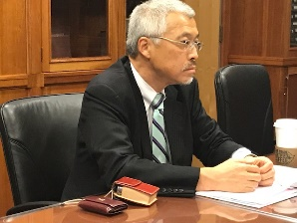
Dr. Masaharu Senu, Okayama University, visited Shepherd University on November 30, for introductory meetings in regard to a pending agreement with the new Graduate School of Interdisciplinary Science and Engineering in Health Systems (ISEHS), scheduled to open in April 2018 at Okayama University. Dr. Seno, Professor of Nanotechnology, also serves as Vice President for International and Interdisciplinary Programs. Discussions centered on unit-to-unit and faculty-to-faculty connections in Nursing and DAIS, with potential opportunities for faculty collaboration in the other natural sciences, economics, global studies, mathematics, and psychology. They also included the development of research and research internship opportunities in STEM, particularly for MedSTEP students considering the MD/PhD research track and for Shepherd students in their capstone process.

ISEHS offers both MS and Ph.D. degrees. They are interdisciplinary and integrate medical science, technology, humanities, and social sciences in seeking solutions that will benefit and be accessible to the greater society. The degree programs will be “globalized”; that is, the language of instruction will be English in order to support their intention to attract an international student body. Hopefully, that may one day include students from Shepherd.

Phi Beta Delta
Honor Society for International Scholars

Established in 1987, Phi Beta Delta is the Honor Society for International Scholars. It recognizes and encourages high professional, personal, and intellectual achievements in international education, international exchange, and internationalization. Shepherd University’s Theta Epsilon chapter was chartered on April 16, 2016, and since then 31 students, faculty, and staff members have been inducted. The next induction ceremony will be held on April 2, 2018. Nominations are currently being sought. For further information, please contact Dr. Aart Holtslag (President) or Dean Ann Marie Legreid (Chapter Coordinator and National Board Member).

In closing, thank you and best wishes for a wonderful 2018!
Global Shepherd (http://www.shepherd.edu/global)

