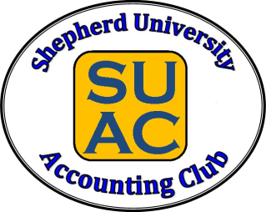 Volunteer Accounting Tutors

Students must schedule tutoring with the tutors by emailing them to set up a tutoring session. The tutor and the student will agree on the time and location for tutoring. This is not affiliated with the Academic Support Center Tutoring Program.
Courses: ACCT 201, ACCT 202, & ACCT 305
Tutor Name: Dakota Luttrell
Tutor Email: DLUTTR01@rams.shepherd.edu

Courses: ACCT 201 & ACCT 202
Tutor Name: Sarah Dillow
Tutor Email: SDILLO04@rams.shepherd.edu

Tutor Name: Marcus Kisner
Tutor Email: MKISNE01@rams.shepherd.edu

Course: ACCT 201
Tutor Name: Denise Wells
Tutor Email: DWELLS03@rams.shepherd.edu

