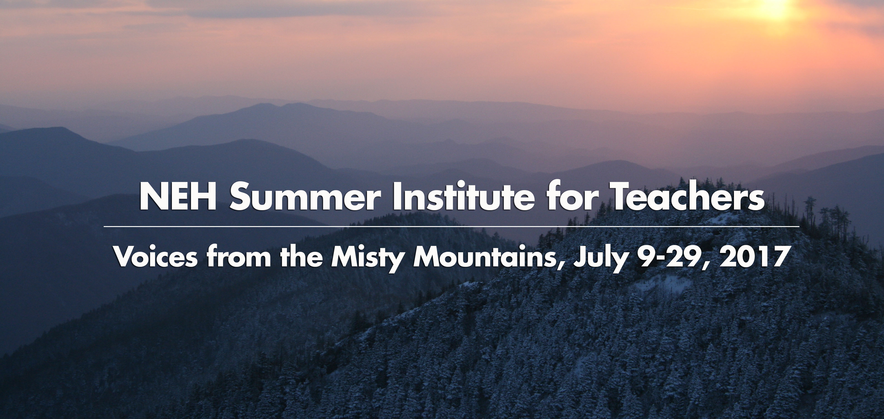
Dear Public School Colleague,
We are pleased to announce our 2017 National Endowment for the Humanities (NEH) Summer Institute for School Teachers: Voices from the Misty Mountains, Appalachian Writers and Mountain Culture. We invite you to join us in Shepherdstown, West Virginia, as we explore an array of Appalachian writers, music-makers, storytellers, traditions and places. Additionally, NEH Summer Scholars will attend the Contemporary American Theater Festival (CATF) and will have the opportunity to work with superb Appalachian playwrights and writers, performers, and CATF actors, who will perform a staged reading of the poetry of Nikki Giovanni. We will also explore with Silas House his writing and dramatic work, as well as the storytelling of Adam Booth and other talented Appalachian artists. Public school scholar-teacher participation in the NEH Summer Institute is supported by a generous grant from the NEH, which provides a stipend designed to help to cover travel, food, lodging, books, and supplies for the institute and tuition if teachers wish to receive graduate credit for their work.
Located on a high bluff of the Potomac River in the heart of the Appalachian Blueridge, Shepherd University is in the center of historic Shepherdstown, West Virginia, the oldest town in the state and originally surveyed by George and Charles Washington. Shepherdstown, with its original Federalist and Victorian buildings and homes, is 65 miles from Washington, DC, and serves as a gateway to the Appalachian region. Shepherdstown is home to the nationally acclaimed Contemporary American Theater Festival, http://www.catf.org/, bringing the “newest plays to the oldest town in West Virginia.” Shepherd University likewise hosts the Appalachian Heritage Writer’s Project and Festival, http://www.shepherd.edu/ahwir, which brings each fall and throughout the year a variety of Appalachian programs to the Eastern Panhandle of West Virginia and surrounding states.
Voices from the Misty Mountains, http://www.shepherd.edu/neh, will run from July 9-29, 2017, and will encourage participants to explore a variety of topics while enjoying this extraordinary and beautiful setting. In addition to reading and discussing a number of literary works and considering the cultural and historical underpinnings provided by the music and storytelling of the region, NEH Summer Scholars will develop a tangible project, such as a teaching unit, a creative project, or a professional conference paper; the iinstitute, therefore, will be both inspirational and practical.
Participants from all over the country and from every discipline and grade level are encouraged to apply, as we seek to bring together an array of diverse voices to enhance and contribute to our understanding of the region. In addition to interacting with CATF actors and Director Ed Herendeen, we will also be joined by Silas House, award-winning novelist and playwright, who will guide participants in exploring themes and ideas about the region and his own works. Another artist’s voice to join participants will be Virginia poet and prose legend Nikki Giovanni, who will discuss her work and extraordinary life with Institute participants. Other writers who will be explored include Ron Rash, Frank X Walker, Denise Giardina, Charles Frazier, Fred Chappell, Jesse Stuart, and others. Scholars and teachers involved in the project include Shepherd University Performing Arts Director and Appalachian native Rachael Meads, who will lead discussions about the music of the region and host a front porch Appalachian Music event and dinner, as food is an important part of Appalachian culture; award-winning storyteller Adam Booth, who will lead the group in a workshop on storytelling; Founding Director of the Contempoary Ameircan Theater Festival, Ed Herendeen and equity actors and staff of CATF, who will share their entusiasm for the dramatic arts; and Seminar Project Director and Appalchian scholar, editor, and 2006 West Virginia Professor of the Year Sylvia Bailey Shurbutt, who will lead discussions about the literature. Theater workshops will also be part of the activities, as performance is an essential part of teaching. The final two days of the seminar agenda (http://www.shepherd.edu/neh/) will conclude with an extraordinary roadtrip, carrying participants through the Appalachian heartland to see some of the sights and places discussed in the seminar, including Hawks Nest, the New River Gorge and Bridge, a West Virginia coal mine and company town, the abandoned railroad town of Thurmond, and the Charleston Cultural Center and Museum.
This NEH Summer Institute for School Teachers is intended for K-12 educators and graduate students who intend to become school teachers, who wish to discover and explore the rich and diverse culture and literature of Appalachia in order to expand their own knowledge and enthusiasm for the diversity of the American cultural landscape and the heritage of a region that is often misunderstood but always fascinating. The Scarbough Library, http://www.shepherd.edu/libweb/, will provide participants with the resources necessary to create practical or creative teaching projects from the Summer Institute for School Teachers. The Shepherd University Graduate Studies Program will offer Professional Graduate Credit to any participants who wish graduate recognition for their work in the seminar.
The deadline for all application materials for Voices from the Misty Mountains is March 1, 2017. Twenty-five participants will be selected from across the country. Interested teachers and graduate students will find links to application materials at the Voices from the Misty Mountains website at http://www.shepherd.edu/neh/ and at the NEH website at http://www.neh.gov/. Applicants will be notified of acceptance on March 31.
Applications must include the official NEH application cover sheet, submitted online at the NEH website: http://www.neh.gov/. Hardcopies of required materials must also be mailed directly to Brenda Feltner, Shepherd University, PO Box 5000, Shepherdstown, WV 25443. The hardcopy package (or a scanned PDF with all materials) must Include the following: 1) copy of NEH Application Cover Sheet; 2) 2-3 page application essay which includes how the Voices from the Misty Mountains Summer Seminar for Teachers will specifically benefit the work of the applicant; 3) Resumé; 4) two letters of recommendation.
Sincerely,
Sylvia Bailey Shurbutt
Sylvia Bailey Shurbutt, NEH Project Director http://www.shepherd.edu/neh Professor of English and Coordinator of Appalachian Studies Shepherd University 304.876.3119, 912.655.2380
Any views, findings, conclusions or recommendations expressed in this website do not necessarily represent those of the National Endpwment for the Humanities.


