Student Teaching
EDUC 449/450/455/456/457/600/601/602/603
Placement Information Packet Instructions
Instructions

- Students are encouraged to contact cooperating teacher(s) as soon as the confirmed student teaching placement is received from the field placement coordinator.
- Students must meet with each assigned cooperating teacher prior to the beginning of the student teaching assignment (September 4, 2017).
- The following dates have been reserved for student teachers to meet with cooperating teacher(s): August 28, 30, 31, & September 1, 2017.
- Please complete the placement information with the cooperating teacher(s).
- Templates for the assignment may be found at: http://www.shepherd.edu/teacher-candidates/.
- Complete the forms for each placement entirely before submission.

Assignment
Schedule |  | Include the title of each class, grade level, start and end times. Also, be sure to list any days school will not be in session: holidays, delays, professional days, or any other modification to the normal schedule.
Outline of Responsibilities |  | Please complete the outline of responsibilities with your cooperating teacher. List the progression of assuming responsibilities by week. Be sure to include all responsibilities including but not limited to: observations, lesson planning, co-teaching, teaching, staff meetings, and professional development sessions. Use the guide below as you develop the outline of responsibilities.  Student Teaching Responsibility Progression  14 Week Placement  Week 1: Observation  Week 2: Begin teaching one period/activity daily using lesson plans you create.  Week 3: Begin teaching a second period/activity daily using lesson plans you create.  Week 4: Begin teaching a third period/activity daily using lesson plans you create.  Week 5-13: Teach all periods/activities daily using lesson plans you create.  Week 14: Near the end of the week, transition responsibility back to the cooperating teacher.  (2) 7 Week Placements  Week 1: Observation  Week 2: Begin teaching one period/activity daily using lesson plans you create.  Week 3: Begin teaching a second period/activity daily using lesson plans you create.  Week 4: Begin teaching a third period/activity daily using lesson plans you create.  Week 5-7: Teach all classes. Near the end of the final week, transition responsibility back to the cooperating teacher.  Week 1: Observation  Week 2: Begin teaching one period/activity daily using lesson plans you create.  Week 3: Begin teaching a second period/activity daily using lesson plans you create.  Week 4: Begin teaching a third period/activity daily using lesson plans you create.  Week 5-7: Teach all classes. Near the end of the final week, transition responsibility back to the cooperating teacher.
Submission

- Students must submit the completed assignment via Tk20 (and email to supervisor) by 9/6/17.
Tk20 Submission Steps | 1. Login: Go to the login page at https://shepherd.tk20.com Log in using the same credentials you use for your Shepherd University email. If your password is not recognized, contact the IT User Support Desk on the lower floor of the library. |  | 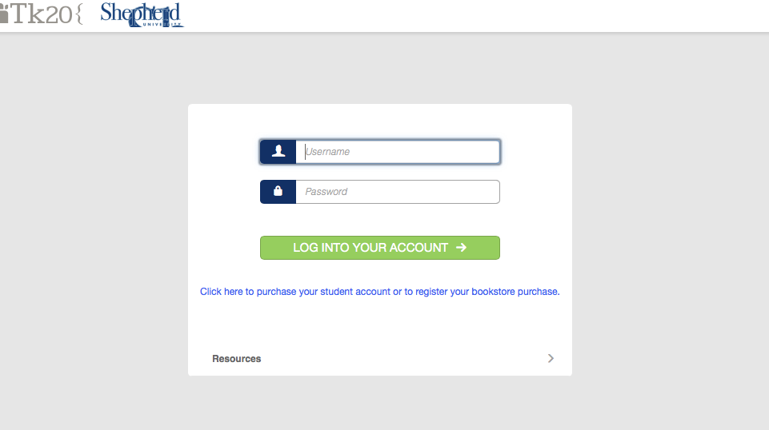
 | 2. From the left menu, click APPLICATIONS.
 | 3. Click the +CREATE NEW APPLICATION button.
 | 4. A dropdown menu will appear. Select PLACEMENT INFORMATION PACKET FALL 2017 from the menu. |  | 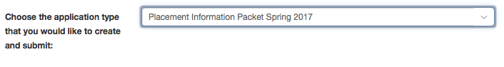
 | 5. Click the NEXT button.
 | 6. Upload completed outline(s) of responsibilities. |  | 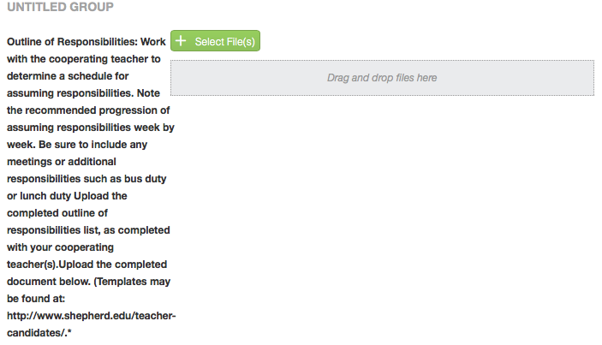
 | 7. Upload completed schedule(s). |  | 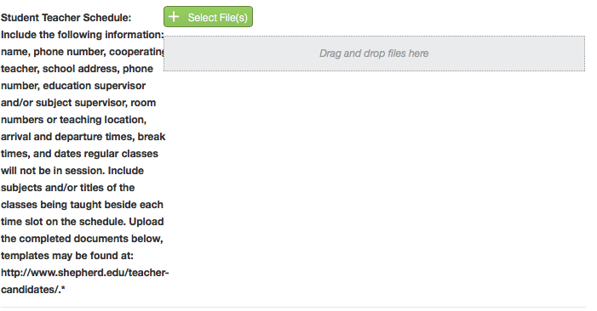
 | 8. Click the SUBMIT button.
Placement Requirements

- Elementary education students: must teach all core subjects.
- Physical education & health students: must teach health in addition to physical education.
- Questions about the schedule of courses may be directed to the student teaching coordinator, Mrs. Helen Baker, hbaker@shepherd.edu.

Student Teacher Outline of Responsibilities
(Samples)

