Shepherd nursing students take part in program

October 15, 2014
Journal News
Save |
SHEPHERDSTOWN - Shepherd University's department of nursing is one of 100 across the country and the only program in West Virginia chosen to take part in a new initiative, a White Coat Ceremony to promote compassionate and patient-centered care.
The Arnold P. Gold Foundation designed White Coat Ceremonies for physicians and surgeons and for more than 20 years they've been a right of passage at medical schools. Now the Gold Foundation, with funding from one of its trustees, Elaine Adler, and her husband Mike, is teaming up with the American Association of Colleges of Nursing to make the ceremonies a tradition for nursing students as well.
On Oct. 3, 58 first-year nursing students participated in the Shepherd University's first White Coat Ceremony. They recited an oath, were cloaked in a white coat, and received a specially designed pin depicting a stethoscope in the shape of a heart that will serve as a reminder of their commitment to provide high quality compassionate care.

Article Photos
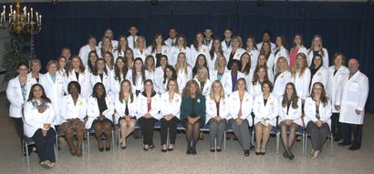
Submitted photo
On Oct. 3, 58 first-year nursing students participated in the Shepherd University’s first White Coat Ceremony.
The keynote speaker for the ceremony was Susan George, associate director of patient care services at the Martinsburg Veterans Affairs Administration Hospital. In 2013 George received the Secretary of Veterans Affairs Award for Excellence in Nursing and for the Advancement of Nursing Programs.
Michael Groves, assistant professor of nursing, said the White Coat program helps emphasize what's already taught at Shepherd-that everything nurses do should be patient-centered.
"It's the patient's life, it's the patient's choices and we're here largely to help guide and teach them, and empower them to take control of their own health," he said.
Groves said the coat and pin also serve as a reminder not to get lost in the science.
"There's a lot of science involved, a lot of technical knowledge that nurses need in order to be able to take care of patients," Groves said. "They are surrounded by equipment, computers, and technology and it's easy sometimes to get lost in the technology and forget that somewhere in that room is a patient who is afraid and has questions and is scared and needs support."
Groves said it's exciting to be one of the first nursing schools to take part in the program.
"It is a chance for us to be part of a new movement and to foster what nursing schools have fostered all along: the idea that all of the medical professions are a good deal of science and a good deal of art and compassion and if either of those things are missing then our patients don't do well," he said.
This year's White Coat Ceremony for nursing students is a pilot program. The Arnold P. Gold Foundation and American Association of Colleges of Nursing plan to expand it to more schools in 2015.

