Tips to Reduce College and Test Stress and Anxiety
- Use a Deep-breathing Exercise to Calm Your Mind
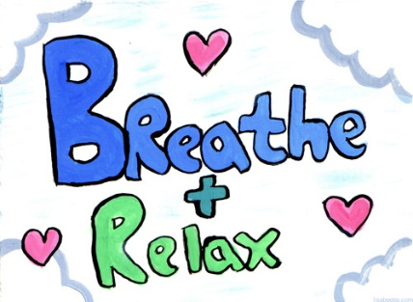
Breathing exercises can get your thoughts off your anxieties and onto your breathing rhythms. Here’s a easy example: 4-4-4-4 Breathing.
Breathe in while counting to 4. Make it a deep, belly breath.
Hold your Breath while counting to 4.
Breathe out while counting to 4.
Hold your Breath while counting to 4.
Do this sequence 2 more times.
- Hard Candy for Hard Times
Consuming food triggers a response in the body that indicates that it is in a safe place. Obviously, eating a full meal isn’t always possible, but eating hard candy such as mints or caramels can calm anxious thoughts and return calm.
- Focus on Sensory Inputs
This is a common trick for alleviating panicked states of mind. Beginning with sight, identify five things you can sense which each of your major senses, except for taste. This focus on sensory inputs distracts the mind and grounds one in what is really happening.
- Take Care of Yourself
Make sure you are meeting all of your needs first, no matter what you need to get done. It is not helpful to go without food, sleep, or anything else you need for any length of time. Deprivation only increases stress, so take care of yourself well!
- Try Meditation
It's simple. Sit up straight with both feet on the floor. Close your eyes. Focus your attention on reciting -- out loud or silently -- a positive mantra. Let any distracting thoughts float by like clouds. It doesn’t work for everyone- some people minds can’t slow down enough to meditate- but it’s definitely worth a try.
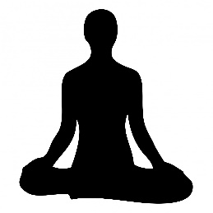

- Take Breaks
When to-do lists grow long, it’s easy to put restful activities to the side. Resist the urge- these activities give your mind time to process stress and put information away effectively. Don’t overwork yourself, and take breaks in longer periods of study or other work. Snack breaks are the best breaks
- Exercise
Whether it’s going on a walk around campus, or an intense gym session, exercise has some direct stress-busting benefits. It pumps up your endorphins. Physical activity helps bump up the production of your brain's feel-good neurotransmitters, endorphins, and ultimately relieves stress.

