Minutes of the September 16, 2015 Regular Meeting of the
Shepherd University Core Curriculum Committee

Chair – Chris Lovelace | present | EDUC – Dawne Burke | present
 |  | HPERS – Greg Place | X
BIOL – David Wing | X | NURS – Laura Clayton | X
CHEM – Robert Warburton | present | Library – Ann Henriksson | present
CSME – Ralph Wojtowicz | X
IES – Ed Snyder | X | Ex Officio:
 |  | Tracy Seffers (Registrar) | X
CAT – David Modler | present | Laura Renninger (Assessment TF) | present
EML – Tim Nixon | present | Anne Bremer (Student Success) | X
HIST – Anders Henriksson | present | Jose Moreno (Multicultural St. Affairs) | present
MCOM – Monica Larson | present | Rachel Crum (Service Learning) | present
MUSC – Erik Jones | present | Emily Gross (Academic Support) | X
 |  | Sylvia Bailey Shurbutt (C&I) | X
ACCT – Cindy Vance | present | Shannon Holliday (FYEX) | X
BADM – Cydne Perry | present | Kahlen Browning (student) | present
ECON – John Schultz | present | Graham Scott (student) | present
PSCI – Stephanie Slocum-Schaffer | present
PSYC – Larry Daily | present
SOWK – Karen Green | X
SOCI – Momodou Darboe | present
The September 16, 2015 meeting of the Shepherd University Core Curriculum Committee was held in the Cumberland Room of the Student Center. Dr. Lovelace called the meeting to order at 4:12 p.m.

- Approval of the minutes from the meeting of 4/15/2015
Larry Daily offered to serve as Core Curriculum Committee Secretary for the 2015-2016 academic year.
One correction to the Minutes was made. In Section IV Course Substitution Committee, the sentence “A student requested to substitute PSCI 210 & 210 for SOCI 405.” Was corrected to read “A student requested to substitute PSCI 210 & 211 for SOCI 405.”
- Announcements
The Chair welcomed new members from Mass Communications, Biology, and the Student Government Association.
The Chair also reminded the committee that the new website (http://www.shepherd.edu/core-curriculum) is now live and he solicited suggestions for changes. He also noted that he has already added the committee’s meeting dates and links to advising resources to the site.
- C&I Report (Dr. Shurbutt).
There was no C&I report from the C&I Chair.
- Course substitution subcommittee
Erik Jones has stepped down as chair of the subcommittee and has been replaced as chair by Karen Green.
The current subcommittee membership is as follows:
Karen Green, chair and Business and Social Sciences
Erik Jones, Arts and Humanities
Ed Snyder, Natural Sciences and Mathematics
Dawne Burke, Education and Professional Studies
There was also a discussion of the subcommittee membership. The discussion centered on the FYEX representative’s position. As it was originally constituted, the subcommittee had five members, one from each of the four academic schools and a FYEX representative. The four school positions are currently filled, but the FYEX position is vacant. After a discussion of the need for a FYEX representative, it was moved and seconded that the FYEX position be eliminated from the subcommittee. The motion passed unanimously.
- First readings
MUSC
Erik Jones presented proposals to add MUSC 311 to Tier 2 as a Writing in the Major course and to delete MUSC 310 (the previous WM course) from the Core Curriculum.
- The what, why, when, and by whom of Core assessment
The Chair asked for guidance concerning the type of assessment plans that the Committee wishes submitted with each course proposal. Committee policy, established when the Core framework was adopted, stipulates that each proposal be accompanied by an assessment plan that included assessments for each of the checked competencies. That requirement was waived during the spring 2011 semester during the rush to populate the framework following its adoption in December 2010. The following year, the committee began enforcing the requirement for assessment plans, but has been ambiguous about what was needed: a plan for every competency checked or just for the “two competencies and two measures” needed for accreditation.
Dean Renninger presented an overview of current Core Curriculum assessment efforts. She then presented two model assessment plans. The first example included only the broad outlines of an assessment plan (e.g., tools to measure experiential learning = test question, project). The second example was much more specific:
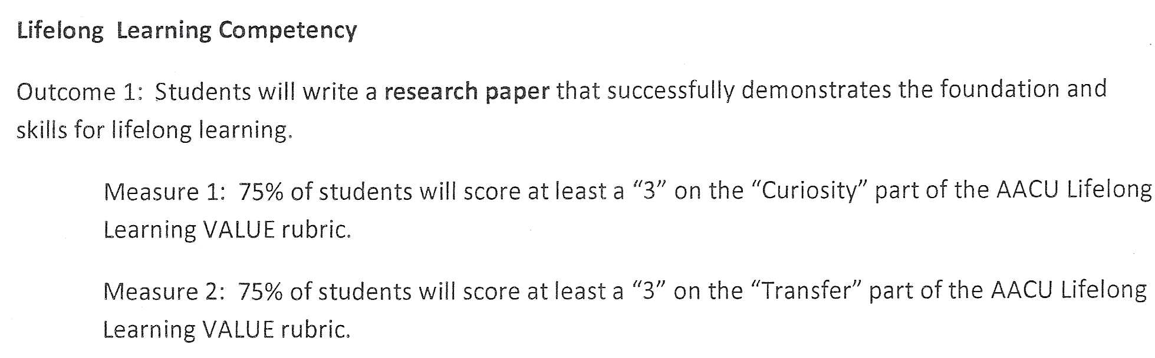
After much discussion, the consensus was that all proposals to add new courses to the Core Curriculum and all proposals to modify courses already in the Core Curriculum should be accompanied by a plan to assess each checked competency. It was noted that departments need not actually conduct these assessments unless called upon by Dean Renninger to do so.
Meeting adjourned at 5:11 p.m.
Respectfully submitted by: Larry Z. Daily

