The Last Ballad By Wiley Cash
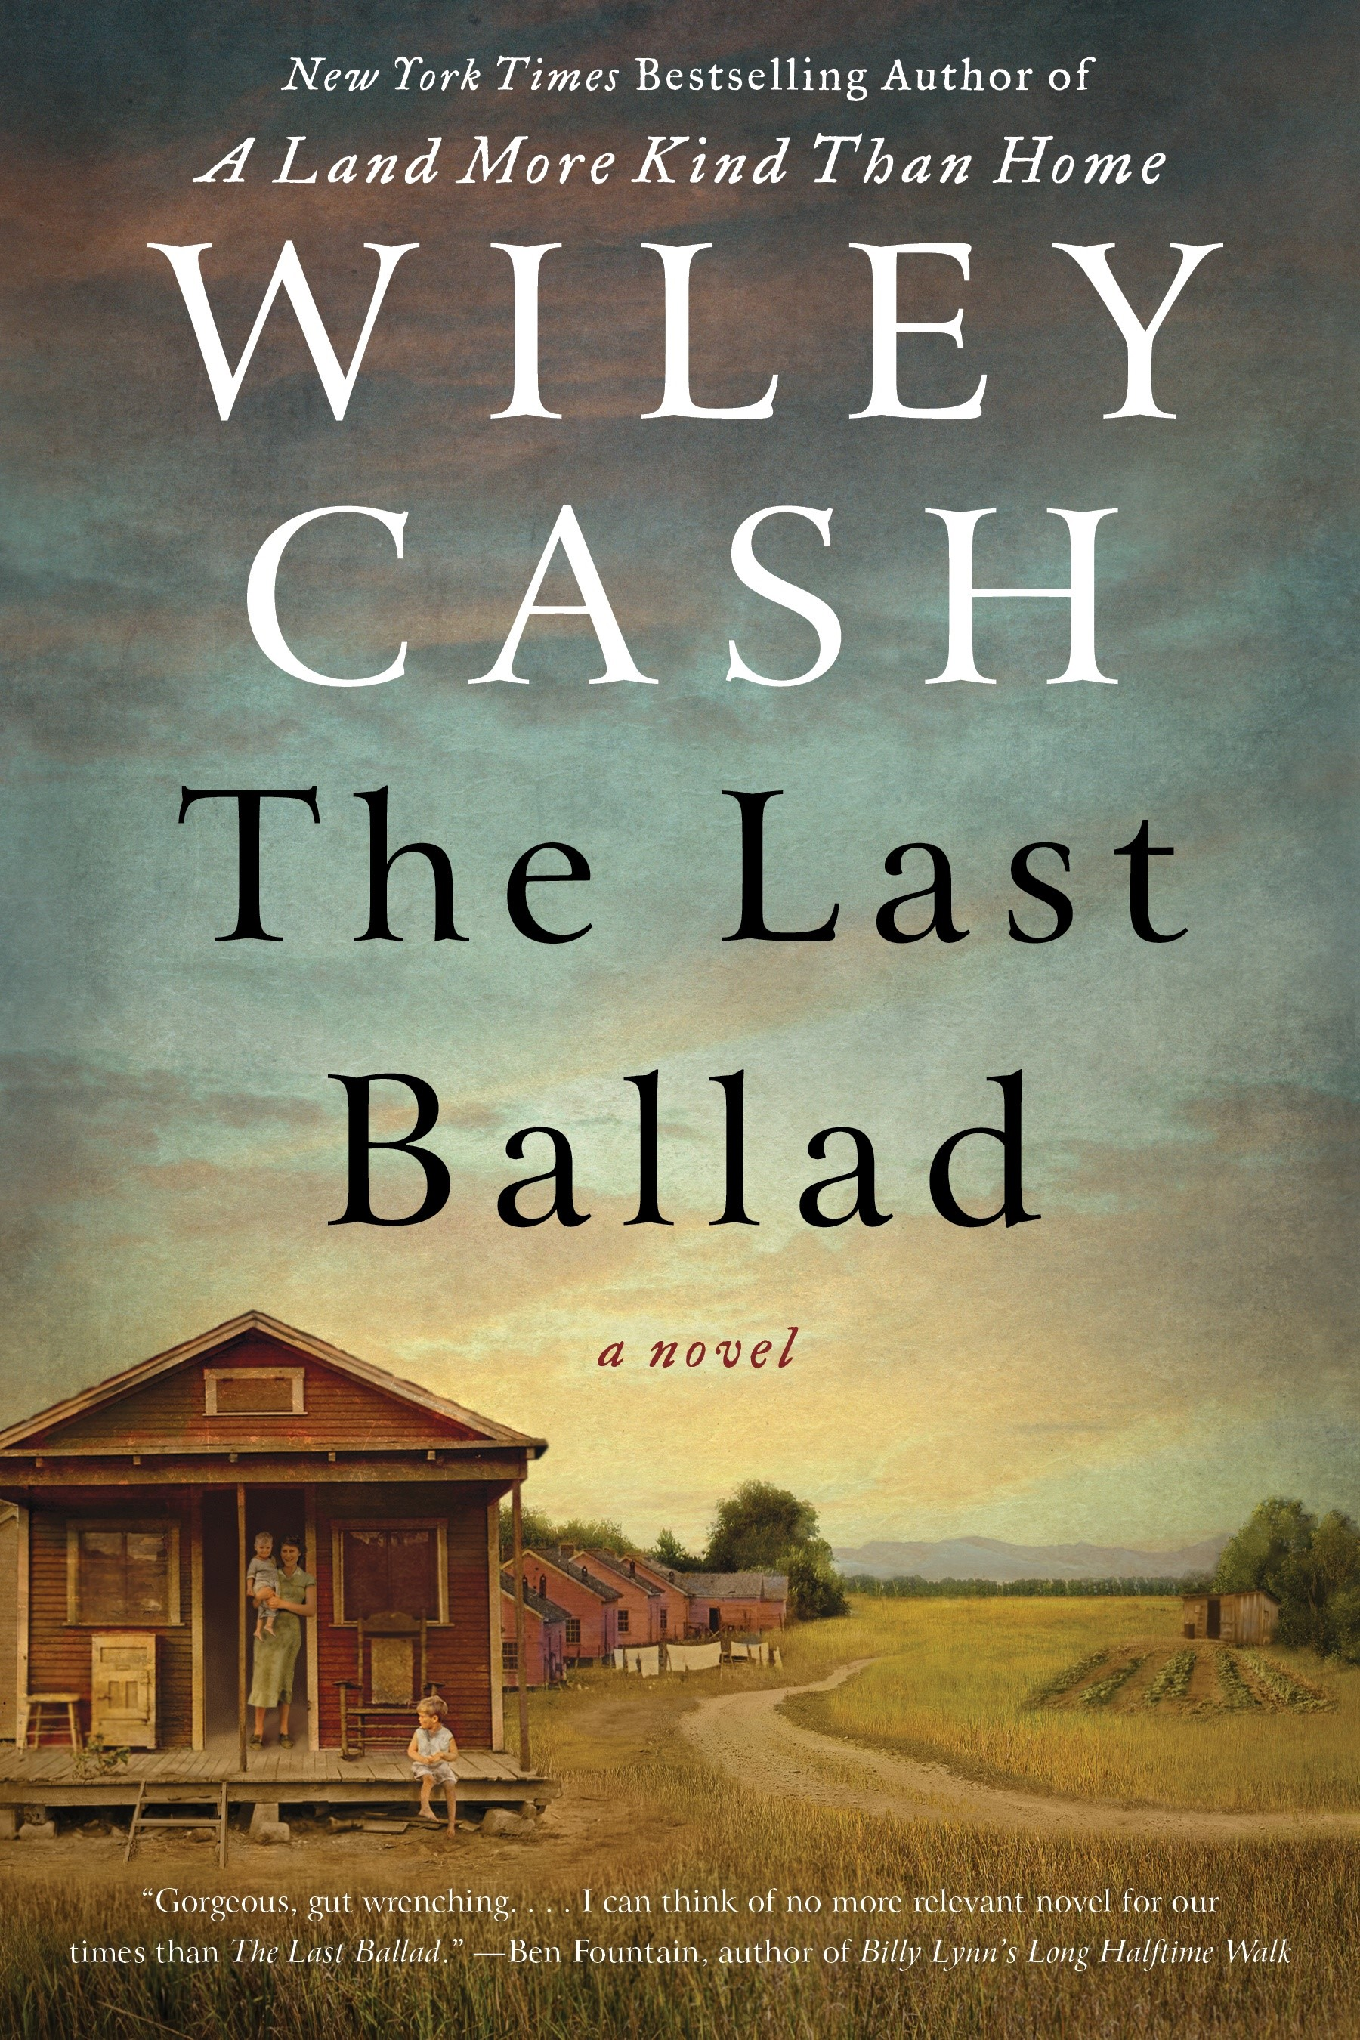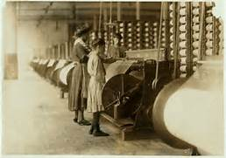
As you prepare to read The Last Ballad, explore the information on the Appalachian Heritage Writer-in-Residence website about Wiley Cash and read the essay that you find under the Teaching Resources and Links: http://www.shepherd.edu/ahwirweb/cash/. Explore this information about the Loray Mill strike in Gastonia, North Carolina; and listen to Pete Seeger tribute to Ella Mae Wiggins (note the misspelling of her name) at https://www.youtube.com/watch?v=Q69onG2nXtg. Since Gastonia, NC, plays such a prominent part in Cash’s work, peruse the links that portray his home town in Gaston County, North Carolina.
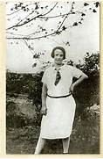 The story that Wiley Cash tells about Ella May Wiggins is based on a true story, thus a departure from his other fiction. Ella May, like many activists, was “formed” by circumstances into a union supporter and outspoken labor leader. What was the incident or circumstance that prompted her to get into the truck that carried her to her first union rally? Why does Ella live in Stumptown and work at the Bessemer American Mill rather than live and work somewhere else like most mill workers? Cash again tells this story through the perceptions or points of view of a variety of participants: Ella, her daughter Lilly, mill-owner Richard McAdam and his daughter Claire and wife Katherine, the redneck bigot Albert Roach, fellow union organizer from New York Hampton Haywood, as well as the local newspapers. This is thus a far more expansive narrative than Cash’s other stories—why do you suppose Cash tells the story this way?
Richard McAdam is one of the few enlightened mill owners in Gaston County and a fairly liberal-minded person for 1929. What is Cash trying to tell us when Richard goes along with the request of Hugo Guyon to contribute men and money to the cause of the Council of Concerned Citizens of Gaston County? Why does Richard do this? How differently does his wife Katherine react to the strike? Claire’s friend Donna makes Claire very uncomfortable by making what analogy to Southern mill workers? When Hampton Haywood comes down south to help Ella organize the African American mill workers, how is he treated by the union boss Beal? What makes Ella’s speeches at the union rallies so appealing, both to Black and White mill workers? What does Richard mean when he answers Epps and Guyon, who threaten to “kill a snake . . . lop off its head” that interferes with their way of life: “And what about this woman? . . . this singer. A snake with its head cut off can still bite you” (201). Why do the mill owners want to drive a wedge between Black and White mill workers? Do you find any contemporary echoes or evocations in such assertions by the owners as “We need to take our city back” (196)? Why is seizing the story narrative, or seizing the language, so important to these rich mill owners? How do they characterize the union and activists in the mill? How does Ella threaten their “narrative”?

